

**Design and Performance Analysis of a Portable Multi-GPU for Artificial Intelligence, Machine Learning and Information Security**

Name of the Team Members (in alphabetical order), *matriculation number*; Foo Chang Jie, *1902190*; Muhammad Azfar Bin Adam, *1902165*; Nicholas Koh Wei Xuan, *1902207*; Wong Chong Peng, *1902128*;

Name of the Industry Supervisor: **Arthur Loo**; Name of the Company: **Professional Officers Division, SIT**

Name of the SIT Academic Supervisor(s): **Goh Weihan**

**ABSTRACT**

Graphics Processing Units (GPUs) have been increasingly used in various IT aspects with examples such as Artificial Intelligence (AI), Machine Learning (ML) as well as Information Security (IS). With the increased usage of such tasks, it is critical to correctly identify the most efficient method to conduct these tasks. There are multiple ways in which GPUs can be connected to form a multi-GPU setup. The most common ways include directly connecting the GPUs to a motherboard, connecting the GPUs via a PCIe switch and connecting the GPUs via riser cards. The aim of this experiment is to find out the optimal setup to perform AI, ML and IS tasks with a multi-GPU setup. The method to determine the optimal setup would be via the use of industry-standard benchmarks based on the aforementioned fields of IT. By performing the same benchmarks on the different GPU setups mentioned before, it would be a clear indication of which setup would be optimal for certain fields. The optimisation will also be done after careful analysis of the results obtained, where different experiments will be done to achieve the optimal setup for each respective field. The goal of this project is to obtain the knowledge of how GPUs can be optimised for these tasks, with hopes of sharing with the community to increase productivity in the field.

# ACKNOWLEDGMENTS

Our thanks to the authors of MLPerf [1], XHPL[2] and Hashcat for allowing us to use their benchmark for our experiment. We would also like to thank ImageNet[3], CocoDataset[4], BraTs[5] and Criteo Terabyte Click Logs[6] for their datasets in our experiment.

The team would also like to thank Asst/P Goh Weihan and Mr Arthur Loo for their support throughout the duration of the project.

# LIST OF TABLES

Our thanks to ACM for allowing us to modify the templates they developed.

Table 1: Abbreviation Table 5

Table 2: Member’s Roles and Responsibilities 12

Table 3: Domains Identified 13

Table 4: Concepts Taught 13

Table 5: Concepts Learnt 13

Table 6: System Hardware Specification 44

Table 7: System Software Specification 44

Table 8: SSD Setup A Training Averages 45

Table 9: SSD Setup B Training Averages 45

Table 10: Hashcat Setup A Results 45

Table 11: Hashcat Setup B Results 46

Table 12: Hashcat Setup C Results 47

Table 13: Combined Comparison Results 47

Table 14: Setup A with Cooling Comparison 48

Table 15: ResNet Setup A Results 49

Table 16: ResNet Setup B Results 49

Table 17: ResNet Setup C Results 50

# 

# LIST OF FIGURES

Our thanks to ACM for allowing us to modify the templates they developed.

Figure 1: An example of SSD’s object detection 17

Figure 2: Detection of an object within bounding boxes 18

Figure 3: ‘Game State’ model for Minigo 18

Figure 4: Mask R-CNN results using COCO dataset 19

Figure 5: Mask R-CNN framework focusing on instance segmentation 19

Figure 6: Residual block snippet 20

Figure 7: Framework involves pretraining and fine-tuning 20

Figure 8: GNMT’s architecture 21

Figure 9: Transformer Architecture 22

Figure 10: The DLRM Model 23

Figure 11: Setup A 24

Figure 12: Setup B 24

Figure 13: PCIe Switch Port Configuration 25

Figure 14: Setup C 25

Figure 15: HPL.dat config 26

Figure 16: M-RCNN run snippet 26

Figure 17: M-RCNN run snippet 2 27

Figure 18: Setup A hashes across iterations 27

Figure 19: Setup B hashes across iterations 28

Figure 20: Setup C hashes across iterations 28

Figure 21: Comparison between Setup A & C for HPL 29

Figure 22: Setup A overview of runs and AP gains over epochs 30

Figure 23: Setup B overview of runs and AP gains over epochs 30

Figure 24: Results from Hashcat between the three setups 31

Figure 25: Average time taken per epoch for SSD 33

Figure 26: Resnet50 throughput results 34

Figure 27: Resnet50 Validation Latency 34

Figure 28: Resnet50 Preprocessing Pipelines 34

Figure 29: GPU boost can depend heavily on power limits 35

Figure 30: Percentage gain compared to baseline 36

Figure 31: ResNet Architecture 51

Figure 32: Minigo Architecture 52

Figure 33: HC Scatter 53

Figure 34: Diagram of chipset 54

Figure 35: Gantt Chart (Project Specification Phase) 55

Figure 36: Gantt Chart (Implementation Phase) 55

Figure 37: Gantt Chart (Analysis and Submission Phase) 55

# ABBREVIATION TABLE

## Table 1. Abbreviation Table

|  |  |
| --- | --- |
| **Abbreviation** | **Paraphrase** |
| **AI** | **Artificial Intelligence** |
| **AP** | **Average Precision** |
| **ARM** | **Advanced RISC Machine** |
| **BERT** | **Bidirectional Encoder Representations from Transformers** |
| **BLAS** | **Basic Linear Algebra Subprograms** |
| **BLEU** | **Bilingual Evaluation Understudy Score** |
| **CIFAR** | **Canadian Institute For Advanced Research** |
| **COCO** | **Common Objects in Context** |
| **CPU** | **Central Processing Unit** |
| **CUDA** | **Compute Unified Device Architecture** |
| **DLRM** | **Deep Learning Recommendation Model** |
| **ESD** | **Electrostatic Discharge** |
| **FLOPS** | **Floating Point per Second** |
| **FPN** | **Feature Pyramid Network** |
| **GLUE** | **General Language Understanding Evaluation** |
| **GNMT** | **Google Neural Machine Translation** |
| **GPU** | **Graphical Processing Unit** |
| **HPC** | **High Performance Computing** |
| **HPL** | **Highly Parallel LinPack** |
| **IS** | **Information Security** |
| **IT** | **Information Technology** |
| **LTS** | **Long Team Support** |
| **mAP** | **mean Average precision** |
| **Mask-RCNN** | **Masked Region-based Convolutional Neural Network** |
| **MCTS** | **Monte Carlo Tree Search** |
| **ML** | **Machine Learning** |
| **MLM** | **Masked-Language Modelling** |
| **MLP** | **Multilayer Perceptron** |
| **MPI** | **Message Passing Interface** |
| **NLP** | **Natural Language Processing** |
| **NMT** | **Neural Machine Translation** |
| **NSP** | **Next Sentence Prediction** |
| **OOV** | **Out-of-Vocabulary** |
| **RCNN** | **Region-based Convolutional Neural Network** |
| **ResNet** | **Residual Network** |
| **RoI** | **Region of Interest** |
| **RoI Align** | **Region of Interest Align** |
| **RoIPool** | **Region of Interest Pooling** |
| **RPN** | **Region Proposal Network** |
| **SQuAD** | **Stanford Question Answering Database** |
| **SSD** | **Single Stage Detection** |
| **SWAG** | **Situations With Adversarial Generations** |
| **TPU** | **Tensor Processing Unit** |
| **tts** | **Text-to-Speech** |
| **VGG** | **Visual Geometry Group** |

# CONTENTS

**ACKNOWLEDGMENTS** **2**

**LIST OF TABLES** **3**

**LIST OF FIGURES** **4**

**ABBREVIATION TABLE** **5**

**CONTENTS** **7**

**INTRODUCTION** **12**

Overview of Document 12

Overview of Project 12

**PROJECT MANAGEMENT** **12**

Gantt Chart 12

Roles and Responsibilities 12

Team Leader 12

Data Analyst 12

Hardware Analyst 12

Safety Officer 12

Communication Channels 13

**MOTIVATION FOR THE PROJECT** **13**

**DOMAIN OF THE PROJECT** **14**

**CONCEPTS TAUGHT** **14**

**NEW CONCEPTS LEARNT** **14**

**AVAILABLE BENCHMARKS** **15**

AI-Benchmark 15

DAWNBench 15

MLPerf 16

DeepBench 16

LamdaLabs 16

Hashcat 17

CUDA accelerated Highly Parallel Linpack (HPL) 17

**BENCHMARKS CHOSEN** **17**

MLPerf 17

Single Stage Detector 18

Minigo 19

Mask Region-based Convolutional Neural Network(Mask-RCNN) 20

ResNet 20

BERT 21

GNMT 22

Transformer 23

DLRM 24

HPL 25

Hashcat 25

**EXPERIMENT SETUPS** **25**

SETUP A 25

SETUP B 26

Specifications of the PCIe Switch 26

SETUP C 27

**BENCHMARK SETUPS** **27**

Hashcat 27

HPL 27

MLPerf 28

Benchmarks excluded 28

**EXPERIMENT RESULTS** **29**

Hashcat 29

Setup A 29

Setup B 29

Setup C 30

HPL 30

Setup A 30

Setup B 30

Setup C 30

MLPerf 31

SSD 31

Setup A 31

Setup B 32

Setup C 32

ResNet 32

Setup A 32

Setup B 32

Setup C 32

**EXPERIMENT COMPARISONS** **32**

Hashcat 32

General Comparison 33

Algorithm 33

Temperature 33

Hardware 34

HPL 34

SSD 34

Bandwidth Bottleneck 34

Inconsistencies of Hardware 35

Resnet 35

Bandwidth Bottleneck 35

Data Augmentation 36

GPU Boost 3.0 37

Power Headroom 37

Voltage 37

Thermal Headroom 38

Boost Binning 38

Thermal Throttling 38

**PCIe Switching** **38**

How PCIe lanes are controlled 39

Why this is relevant to us 39

**CONCLUSION** **39**

**CHALLENGES FACED** **39**

Hardware compatibility 39

Time consuming benchmarks 40

**FUTURE WORKS** **40**

MLPerf Modules 40

Extra Equipment 40

**LESSONS LEARNT** **40**

**Foo Chang Jie** **40**

Muhammad Azfar Bin Adam 41

Nicholas Koh Wei Xuan 41

Wong Chong Peng 41

**APPENDIX** **41**

Installation Guide 41

SSD 41

Minigo 42

Mask-RCNN 43

ResNet 44

TABLES 45

FIGURES 53

ResNet Architecture 53

Minigo Architecture 54

HC Scatter 55

HC Scatter 55

GANTT CHART 57

**REFERENCES** **58**

# INTRODUCTION

This section will provide readers with an overview of the document, as well as a general overview of the project to give readers some background understanding on the premise of our project.

## Overview of Document

This document contains 16 sections with 60 pages. The sections include: INTRODUCTION, PROJECT MANAGEMENT, MOTIVATION FOR THE PROJECT, DOMAIN OF THE PROJECT, CONCEPTS TAUGHT, NEW CONCEPTS LEARNT, AVAILABLE BENCHMARKS, BENCHMARKS CHOSEN, EXPERIMENT SETUP, BENCHMARK SETUP, EXPERIMENT RESULTS, EXPERIMENT COMPARISON, CONCLUSION, CHALLENGES FACED, FUTURE WORKS, LESSONS LEARNT, APPENDIX

Some parts of the document require constant references to the APPENDIX. The experiment results’ raw data, as well as configurations and implementations, can be found in our GitHub repository: <https://github.com/nickwx97/IS10-ITP>

## Overview of Project

The main objective of the project is to explore the possibilities of a Multi-GPU setup, with the main focus of analysing the impact of these setups on the performance of Artificial Intelligence, Machine Learning as well as Information Security. With the rise of GPU usage for tasks in the aspects mentioned before, it is critical for us to understand and find out which setup would affect the performance for these tasks. This project aims to analyse the different types of multi-GPU setups alongside a stock setup to compare and find the optimal setup, with reasonable thesis and reasoning to the results obtained to assist the community in this field.

# PROJECT MANAGEMENT

This section will provide readers with information on the team’s approach to tackle this project. A timeline of project tasks, roles and responsibilities as well as means of communication are documented in this section.

## Gantt Chart

Snippets of the are included in a section in the Appendix as Figures 35-37, where it contains the planned completion of tasks done by each team member. The Gantt Chart has received many revisions due to the team’s discussion and the Gantt Chart below is the latest version prior to project submission.

## Roles and Responsibilities

#### Team Leader

Overall in charge of the project, coordinates deliverables to ensure the team is heading in the correct direction. The team lead also manages team performance and sorts out any issues the team faces with the lecturer in charge.

#### Data Analyst

The data analyst takes charge of analyzing the data obtained from the benchmarks to understand and make sense of the data obtained. The data obtained can then be compared with other setups, where information could be drawn from the results obtained.

#### Hardware Analyst

The Hardware Analyst takes charge of researching the specifications of our machine, the hardware differences between the different setups and makes use of the data analyzed to correlate it to the hardware side of the project.

#### Safety Officer

As team members deal in hardware for this project, the team may be required to switch the setups around for different benchmarking. Team members must look out for one another in terms of safety. The safety officer takes charge of ensuring the environment is safe before working on the machine. The safety officer also ensures that the setup remains safe from ESD and physical damages.

## Table 2. Member’s Roles and Responsibilities

|  |  |  |
| --- | --- | --- |
| **Team Member** | **Roles Assigned** | **Responsibilities** |
| Foo Chang Jie | Team Leader  Data Analyst  Safety Officer | * Keep track of deadlines, plan for mitigations * Assign tasks * Perform allocated task |
| Muhammad Azfar Bin Adam | Data Analyst | * Perform allocated task |
| Nicholas Koh Wei Xuan | Hardware Analyst  Safety Officer | * Perform allocated task |
| Wong Chong Peng | Hardware Analyst | * Perform allocated task |

## Communication Channels

Due to the COVID-19 outbreak, there was a limited number of people that can be together per group, which made meeting up on the campus impossible for a period of time. The team has decided to make use of an online platform - Discord, where we can have a direct communication channel with the Academic Supervisor, who is also inside the chat. The team has a weekly meeting every Sunday night on Discord, where team members would update one another on their progress and perform the planning of tasks for the upcoming week. The team also makes use of Telegram, an instant messaging application for short and quick communications that is readily available to all team members on the go.

# MOTIVATION FOR THE PROJECT

This section will provide readers with the team’s main driving force for this project, as well as the impact that this project may bring to the rest of the community.

The main driving force for this project is the increased usage of GPUs in the various Information Technology aspects. GPUs were mainly used as a tool for 3D graphics rendering, and are considered “fixed function processors” [7], with only one role. However, as the years pass and technology advances, GPUs have also advanced in their own right. NVIDIA, a company that focuses on designing GPUs, started to make GPUs more programmable, which made parallelism possible for certain tasks. This led to the optimisation of GPU chips, which made it possible for these chips to be used in fields like Machine Learning as well as Blockchain. Recent trends have also shown the general interest in cryptocurrency mining, with GPU price increase due to the shortage of GPUs available in the market [8].

With the usage of GPUs constantly increasing, it brings about multiple important questions that need to be asked. There are multiple ways of connecting a GPU to a computer - it could be plugged into the motherboard or connected externally via the use of riser cables to convert the x1 PCIe slots to fit in more graphics cards. What are the differences between having this particular setup with the setup that allows the same amount of GPUs to be connected directly to the motherboard? Is there any way to optimise the way we use our GPUs to complete our tasks?

These questions can be answered by performing the same benchmark on the different setups. There are many benchmarks out on the market that can perform intensive tests on fields like Machine Learning and Artificial Intelligence, where we can then carefully analyse and learn how the different setups will have different impacts on performance in these fields. With this information, GPU usage can be more efficiently utilized and bring about increased output in various fields from the increased efficiency.

# DOMAIN OF THE PROJECT

This section will provide readers with the scope as well as the different aspects of fields that this project has relations to via a table.

## Table 3. Domains Identified

|  |  |
| --- | --- |
| Domain | How it is used |
| Artificial Intelligence | AI is used as part of the criteria for the performance analysis of GPUs in this project. Benchmarks based on AI will be used, and knowledge on AI is required to understand how and what the benchmarks do to identify the cause of results through different setups |
| Machine Learning | ML is also one of the criteria for the performance analysis of GPUs. Benchmarks based on ML will be used and knowledge in this field would help identify the cause of differences through multiple setups. |

# CONCEPTS TAUGHT

This section will provide readers with the concepts that were taught on campus that are related to this project, and how it has aided the team in the completion of this project via a table.

## Table 4. Concepts Taught

|  |  |
| --- | --- |
| Concept | How it is used |
| Computer Organisation and Architecture | The understanding of how a computer operates, as well as how each part works to perform tasks is critical to this project as it is required to identify the difference in performance between the systems. |

# NEW CONCEPTS LEARNT

This section will provide readers with the new concepts that the team has come to learn and explore throughout this project via a table.

## Table 5. Concepts Learnt

|  |  |
| --- | --- |
| Concept | How it is used |
| Artificial Intelligence | AI/ML is not a term that is new to the team, as it is widely used in our field. However, the implementation of tools on AI is something new to the team. Through this project, the team has come into contact with AI via different benchmarks. Some domains of AI that the team has come in contact with include ML, Computer Vision as well as NLP. |
| Machine Learning | Similar to AI, ML is a field that the team does not have much exposure to in terms of implementation. ML is used in the benchmarks that the team has identified via the usage of AI domains to train models to reach a certain standard in various AI domains. One example of ML that the team has come in contact with would be Reinforcement Learning via Minigo from the MLPerf suite. |
| Hardware Optimisation and Analysis | This project is based on different setups of the GPUs and how it affects performance based on different fields. The team has to do proper research on equipment such as riser cables and PCIe switches to understand what they do and come up with a design that would fit the project’s needs. |

# AVAILABLE BENCHMARKS

This section will provide readers with a brief understanding of the different benchmarks the team has considered for this project.

A benchmark is a standard or a point of reference in which different things can be compared under the same premises. In our premise, the different setups that the team will be using will be running the same benchmark under similar circumstances to obtain a valid comparison between different setups.

For the team to obtain accurate comparisons in different aspects such as AI, ML as well as IS, different benchmarks specializing in their respective fields are used. Many benchmarks are available on the web that does similar tasks, thus it is important to choose a benchmark that can fulfil our requirements, namely perform benchmarks that are being approved by the industry, as well as the benchmark, should be able to run their tests across multiple GPUs, as that scenario is one of our setups in our experiment.

* 1. **Artificial Intelligence & Machine Learning**

AI refers to the simulation of human intelligence within machines, with examples being planning and learning and that machines can execute tasks with a certain degree of intelligence. ML would be more about machines being able to learn and adapt through multiple iterations, where both AI and ML’s interests would coincide, as ML is a subset of AI.

There are many different ways to measure the efficiency of GPUs for AI and ML, the measuring stick for these are efficiency, where GPUs are required to be able to process massive quantities of data in the shortest time possible. There are 4 main key indicators for benchmarking with relation to AI and ML are Data capacity, training speed, model precision and inference speed.

Data capacity refers to the number of samples that the setup can process, training speed refers to the time required to train the model to a certain accuracy level. Model precision refers to the development of the model to attain high accuracy and inference speed refers to the response time taken to calculate the outputs from the model based on the test case. These four key indicators’ ideology can be found with the benchmarks that have been implemented below.

#### AI-Benchmark

AI-Benchmark is an open-source python library that aims to evaluate AI performance over different hardware setups that are available such as CPUs, GPUs as well as TPUs. The goal of AI-Benchmark is to create a professional, accurate and lightweight tool for the field of Artificial Intelligence as well as Machine Learning [9].

AI-Benchmark consists of 42 different tests from 19 sections. The tests include image classification, image-to-image mapping, image segmentation, text translation, sentence sentiment analysis and many more. AI-Benchmark does these modules in-depth, as the same tests are done on different architectures such as MobileNet and neural networks such as Inception V2 to gain more data by doing more tests.

AI-Benchmark has its public ranking, where they try to keep its benchmark as an open standard for the public. AI-Benchmark allows public users to submit their benchmark results to them and the ranking for the different GPUs will be updated every few weeks based on the results that they received and tabulated. AI-Benchmark hopes to achieve more datasets showing the speed of training/inference for the different AI models that they have included into the benchmarks on more GPUs that are being used commercially. By having a wider range of results received from the public, it gives them more data on comparing the performance of different drivers and configurations, software platforms and framework builds and sees if they are related to one another.

#### DAWNBench

DAWNBench is one of the first benchmark suites ever created that is used to benchmark GPUs based on end-to-end deep learning training as well as inference. DAWNBench has two modules in their suite: Image Classification as well as Question Answering. Each module makes use of industrial-based datasets with examples such as CIFAR-10 and ImageNet for image classification as well as SQuAD for Question Answering. DAWNBench’s results are based on four main criteria, namely: training time, training cost, inference latency as well as inference cost.

However, support for DAWNBench ceased in 2018, and the team behind DAWNBench has collaborated with the team of MLPerf to create a more comprehensive benchmark suite with more tasks and scenarios [10]. The modules that are within DAWNBench as of 2021 are considered obsolete, with more updated datasets as well as neural networks and when compared to other benchmarks, with more features covering different modules other than image classification and question answering, DAWNBench falls short.

#### MLPerf

MLPerf is a benchmarking suite focused on benchmarking Machine Learning tasks. MLPerf is made by a group of AI leaders from various industries, academia as well as research labs, intending to create a fair and useful benchmark for the community.

MLPerf consists of various machine learning and artificial intelligence reference implementation models, namely ResNet-50, SSD, Mask R-CNN, GNMT, Transformer, BERT, DLRM & Minigo. The benchmark models are categorized into different areas such as vision, language, commerce and research. Each implementation model is based on a benchmark, such as image classification, object detection, reinforcement learning, etc. A full table can be accessed at the MLPerf webpage [11].

#### DeepBench

Released in 2016 by one of the largest AI companies in China (Baidu, Inc.), the microbenchmark suite DeepBench analyzes basic, low-level operations like matrix multiplication as well as dealing with recurrent layers. It handles both inference and training. DeepBench’s main focus is on assessing hardware performance at the kernel level. Its goal is to benchmark the deep learning model’s underlying operations [12].

Baidu’s DeepBench has deep learning operations that cover a wide range of applications in machine learning. Some applications mentioned by the benchmark include DeepSpeech, Language Modeling, Machine Translation, Speaker Identification, etc.

Although DeepBench can operate on a variety of hardware platforms, it is worth noting that it is a difficult benchmark to utilise CPUs with a non-x86 architecture. This is because only some ARM CPUs can work with DeepBench. DeepBench’s code as well as the supporting libraries on ARM CPUs have to be modified due to the many bugs present when attempting to run the benchmark. Furthermore, the datasets used on the many different hardware were not consistent with one another. As a result, this makes for an inaccurate result when comparing the performance [13].

Given that DeepBench is an old benchmark, Baidu has worked hand-in-hand with other companies to release the newer benchmark known as MLPerf. MLPerf measures the time required to achieve a given accuracy of a deep learning model trained on a fixed dataset. It assesses the time it takes for a deep learning model that is trained using a fixed dataset to reach an acceptable level of accuracy [14]. This method allows benchmark model performance across different hardware systems.

#### LamdaLabs

Lambda’s GPU benchmark is another benchmark suite created for deep learning. Using popular machine learning frameworks such as Tensorflow and Pytorch, it offers many popular benchmarks for categories in Computer Vision, NLP, and tts, etc. AI and machine learning models such as SSD, Resnet50, MaskRCNN, GNMT, BERT, Transformer, and others are supported by the benchmark stack.

Lambda’s GPU benchmark methodology measures the effectiveness of GPUs in training neural networks using training throughput as the measuring stick. The training throughput measures the number of samples processed per second by the GPU instead of FLOPS. Training throughput is strongly correlated with time to solution. With a higher training throughput, the GPU can process a larger dataset more quickly and teach it faster, the better the GPU effectiveness [15]. Lambda’s PyTorch benchmarks is a wrapper to NVIDIA’s DeepLearningExample repo which is optimised and submitted in MLperf.

* 1. **Information Security**

There are tasks in IS that make use of the computing powers of the GPU. One good example would be hash cracking. Utilizing the computation power of a GPU allows the running of multiple instructions in parallel with thousands of processor cores running simultaneously when compared to the limited processor cores that the CPU has. It has also been a topic that has been researched on, with equally priced GPUs and CPUs output that GPUs can perform up to 30 times faster than a CPU [16]. Given the use of GPUs in this field, the team feels that a benchmark to gauge this field is required and with the correct setup, could lead to more efficient methods of cracking hashes.

#### Hashcat

Hashcat is a widely-known, powerful password cracker that is openly available. Besides being used for password cracking, Hashcat has a built-in benchmark utility to test how many hashes it can crack per second using either CPU or GPU. Hashcat benchmark utility supports many different hashing algorithms including popular hashing algorithms like SHA, MD5, etc.

* 1. **Floating-point Computing Power**

FLOPS is a gauge for measuring computer performance, specifically the mathematical throughput of processing cores. Many fields, including AI, ML and IS make use of floating-point operations as part of their operations. Some examples would include image processing [17] and precision training for ML tasks. The goal for including this FLOPS gauge is to verify the computational power of the GPUs with a different setup, to verify that the computational speed of the setup is not being compromised with additions of different hardware.

#### CUDA accelerated Highly Parallel Linpack (HPL)

Released in 1979, LINPACK benchmarks are widely used to measure a system’s floating-point computing power. It utilizes BLAS, Basic Linear Algebra Subprograms, to perform basic vector and matrix operations. To date, these benchmarks are used to populate the TOP500 list, which is a list of the world’s most powerful supercomputers. The benchmark is designed to simulate real problems to calculate how fast a system will perform when solving it. It consists of 64-bit floating-point operations, addition and multiplication in general, and it quantifies the system performance in FLOPS, which stands for FLoating-point Operations Per Second.

LINPACK, however, is not suitable for testing parallel computers and thus HPLinpack (HPL) was created for that purpose. It is a portable implementation, written in C, which is still currently used to populate the TOP500 list. It provides a testing and timing program to measure the accuracy of the obtained solution and the time taken to compute said solution [2].

The aforementioned LINPACK and HPL benchmarks were designed with CPUs in mind. As we want to benchmark different GPU setups, we decided on using NVIDIA’s implementation of the benchmark, where they use CUDA to accelerate the Linpack benchmark on heterogeneous clusters. The implementation allows both the CPUs and GPUs to be used with minor modifications to the original source code [18].

# BENCHMARKS CHOSEN

This section will provide the readers with reasoning as to why the team chose to proceed with the experiment with the benchmarks that were selected.

There are several requirements that the benchmark must meet for this experiment. The benchmark must be properly recognized by the general public. An industrial benchmark made for such fields is preferred as it would serve to increase the validity of the team’s claims, and would allow members of the field to replicate and verify the results for themselves. In addition, the benchmarks that the team chooses must cover a wide spectrum of fields. Lastly, the benchmark must also be able to run tests across multiple GPUs, as that is what the experiment’s basis is about.

## MLPerf

MLPerf is regarded as an industry-standard benchmark for machine learning [19]. The reasoning behind it is because it is a fair benchmark, containing modules that test a machine’s capabilities in several major aspects of Machine Learning. Some of the modules include vision, reinforcement learning, recommendation and many more. In addition to this, MLPerf has strived to be better by working with commercial companies such as NVIDIA, as well as academic organizations such as Harvard [19]. The MLPerf team takes into consideration and feedback from these organisations as well as doing constant research on the current Machine Learning scene to ensure that MLPerf maintains relevancy. This is also evident by the consistent updates on the repository from MLPerf as well. The relevancy of MLPerf compared to some of the other benchmarks which have not been updated or supported like DAWNBench, puts MLPerf as our top pick for the experiment.

Other than being an industrial standard suite, another reason why MLPerf was chosen over some of the other benchmarks is because of its reliability to our project. Our experiment requires the benchmark to be able to work for systems with multiple GPUs. Some benchmarks such as AI-Benchmark, do not support the feature of multi-GPUs and would not help in our experiment when we are comparing the different setups. MLPerf was designed to benchmark systems with multiple GPUs and would be a perfect choice for being the benchmark for our experiment.

The final reason why MLPerf was chosen as one of our benchmarks is because of the bigger user base for this benchmark by the public. Even though MLPerf was designed to benchmark powerful systems with better capabilities when compared to our system, there are benchmark results that are posted on the MLPerf repository where we can compare our results to other systems. Having different results available allows us to compare and cross verify if the benchmark that we have conducted is accurate to a certain degree. When we compare the availability of cross-referencing results with other benchmarks like DeepBench or LamdaLabs benchmark, MLPerf would stand out more as a better benchmark for this aspect.

The above mentioned would be some of the key reasons why the team chose MLPerf as one of the benchmarks to use for our experiment. However, to understand more about MLPerf, it is important to know what the benchmark does and what it tests for. Below are some of the modules that MLPerf does and why it is useful in the field of Machine Learning and Artificial Intelligence.

#### Single Stage Detector

SSD is an object detection network, one example of SSD would be the detection of multiple objects within a single photo as shown in Figure 1.

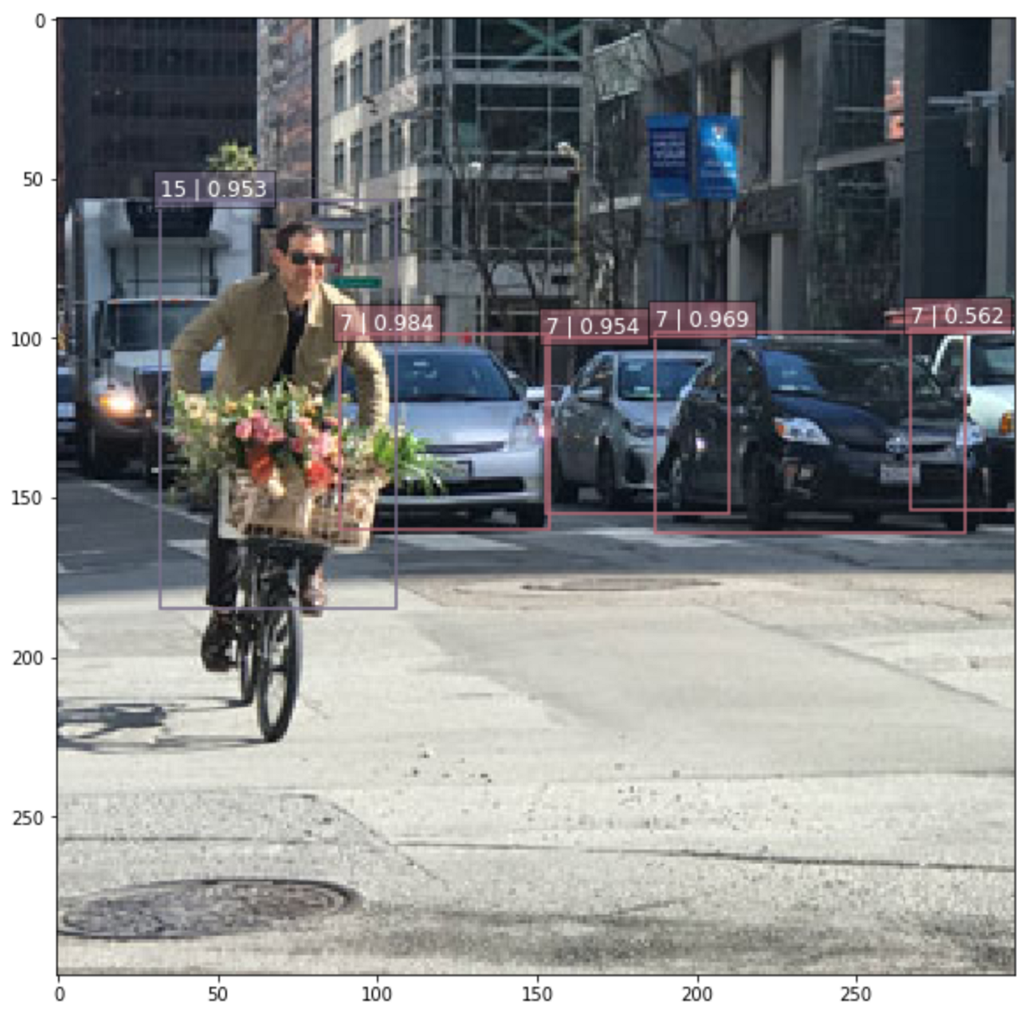

## Figure 1. An example of SSD’s object detection [20]

SSD takes in the whole image and uses object detection and classification to identify the potential objects within the photo. SSD has two main processes in detecting objects in an image, SSD is required to extract feature maps and apply convolution filters to detect objects. A feature map is a mapping that contains parts of an image, split into cells of specific sizes. For example in Figure 1, the image is split to an 8 by 8 feature map. SSD will then make use of the cells to determine objects within multiple cells. A point system is used to determine if there are potential objects and once a certain threshold is hit, SSD will highlight the box and take note of it as an object within the boundary box.



## Figure 2. Detection of an object within bounding boxes

SSD tries to detect images by splitting the image received into bounding boxes and gives a score to each box for the presence of an object that could potentially exist as depicted in Figure 2. This process is then repeated for multiple objects within the same image, where SSD is able to handle these processes in parallel. If any object is detected via this means, a scoring system will take place on the box’s coordinates to determine the category of the object. The object found will then be tagged with the category with the highest score. This module aims to train the model such that it reaches a quality target of 0.23 mAP. The quality target is checked after every 5 iterations, and will stop once its quality target is met.

#### Minigo

Minigo is one of MLPerf’s modules that aims to focus on the field of reinforcement learning, a major part of ML. Reinforcement learning is the training of a machine model to make a series of decisions. In Minigo’s case, it involves making use of neural networks to train a model to be proficient at Go, an abstract strategy board game.

To train the model, the initial model will play the game against itself for 25,000 iterations to produce the first few steps of the game, as well as to learn the board positionings for Go. After each move, the neural network stores three vital pieces of information to help the network learn and improve the game of Go. The game state, as shown in Figure 3, which contains a stack of board information, such as positioning for each piece, the search probabilities, which come from the model’s methodology of choosing the next move via the MCTS, as well as the winner, if that particular move is the winning move.

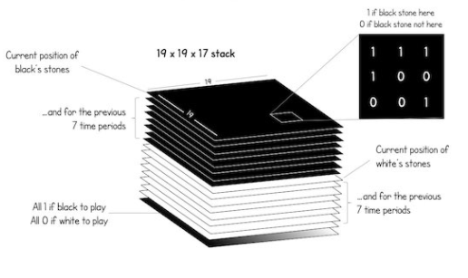

## Figure 3. ‘Game State’ model for Minigo [21]

MCTS makes use of various parameters to determine the next best move, as well as the methodology of collecting information for the model. After processing a list of best moves, the model will make a decision based on the context: if the model is playing against another model, it would use the deterministic approach, which chooses the best possible outcome for competitive play. If the model is playing against itself and is doing the iterations for exploration purposes, the stochastic approach will be used. A clearer visual guide on the selection of the best moves can be found on the Alphago document [22] in the appendix.

After training the model to a certain extent, the current best model will go through an evaluation, where the model will play against a fixed target model for 256 games. The quality target for this module is that the model that the benchmark is training will have a win rate of at least 50% against the target model. If the model manages to hit this target, the training benchmark will stop, if not, a new model will be chosen by playing with other models and facing the target model in the next loop. The cycle will stop once the benchmark model achieves at least 50% wins against the target model.

#### Mask Region-based Convolutional Neural Network(Mask-RCNN)

Mask-RCNN is another MLPerf’s module that aims to solve object instance segmentation problems in computer vision. One of its objectives is to be able to detect objects in an image. Additionally, its other focus is on producing a high-quality segmentation mask for each instance. The goal for this is to categorize each pixel into a predetermined set of categories without distinguishing between object instances [23]. A mask has the task of encoding the spatial arrangement of an input object. This informs sequence-processing layers of the presence of missing timesteps found in inputs.

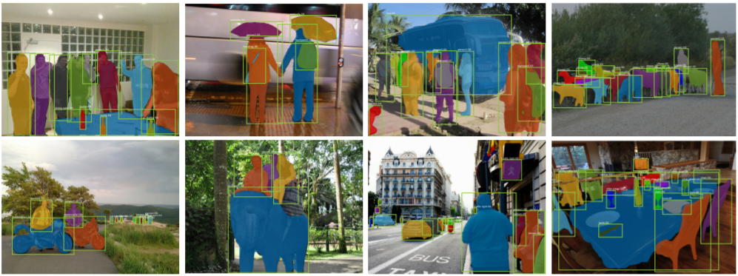

## Figure 4. Mask R-CNN results using COCO dataset

Mask R-CNN is essentially an enhancement of Faster R-CNN. Made up of three stages, the first involves object detection where an RPN creates ‘proposals’ at regions where objects exist leading to the creation of object bounding boxes. The second stage is basically Fast R-CNN which is the predecessor to Faster R-CNN. It uses RoIPool to extract features from the boxes and is capable of doing classification and bounding-box regression. Faster R-CNN, on the other hand, was not built for pixel-to-pixel alignment between network inputs and outputs and this led to the third stage and the creation of Mask R-CNN [23].

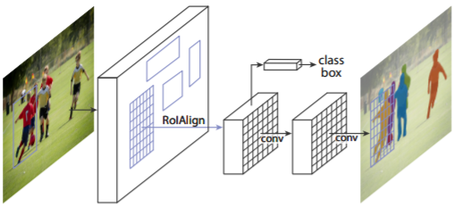

## Figure 5. Mask R-CNN framework focusing on instance segmentation

Mask R-CNN improves upon Faster R-CNN as it adds a mask branch for predicting segmentation masks for each ROI. The mask branch is applied to each RoI and operates pixel-by-pixel to anticipate the segmentation mask. RoIAlign solves the issue of the pixel-to-pixel alignment mismatch. The basic method for extracting a small feature map from each RoI is known as RoIPool. It first quantizes a floating-number RoI to the discrete granularity of the feature map, then subdivides the quantized RoI into spatial bins, which are subsequently quantized, and lastly aggregates the feature values represented by each bin. Quantization has the problem of introducing misalignments between the RoI and the derived features. This has a significant detrimental impact on pixel-accurate mask prediction. Fortunately, this is where the enhancement comes in useful. The quantization of RoIPool at the RoI borders is removed by a RoIAlign layer, which aligns the derived features with the input. There is no quantization applied to any of the coordinates in the RoI, its bins, or the sampling points. As a result, RoIAlign accurately retains the precise spatial positions and enhances mask accuracy from 10% to 50% [23]. Mask R-CNN makes use of the COCO dataset with an aim to hit a quality target of 0.377 Box min AP and 0.339 Mask min AP [11].

#### ResNet

ResNet is a deep residual learning network that does image recognition. Instead of learning unreferenced functions like other models, layers are formulated as learning residual functions that reference the layer inputs [24]. The main goal of ResNet is to build a deeper neural network, via identity mapping, where the network will make use of identities to maintain the accuracy as well as the error rate and also via consistent learning of the residuals to be able to keep both the predicted and the actual matched. To do this, ResNet introduced Residual blocks, where there are connections that could be skipped in some layers in between, which is also known as the ‘skip connection’ as depicted in Figure 6.

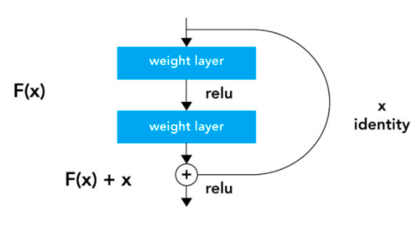

## Figure 6. Residual block snippet

With the skip connection, it gives network models a faster way to flow through by learning the identity functions. This greatly improved the performance for different neural networks with more networks [25]. An example of the ResNet model’s architecture can be found in section C.i of the Appendix, where it can be seen compared to previous implementations of non-skip connections.

This kind of model can have a maximum depth of 152 layers, which is 8 times deeper than the model that VGG created, which has a maximum depth of 19, and still has lower complexity when compared to it. For MLPerf’s benchmark, they have implemented ResNet50 v1.5.

### BERT

BERT is a machine learning method for NLP. It is developed with the aim of pretraining deep bidirectional representations from the unlabeled text. This is done by conditioning all layers jointly on both the right and left context [26]. BERT is capable of a variety of tasks including question answering and language inference. Its framework is made up of pre-training and fine-tuning.

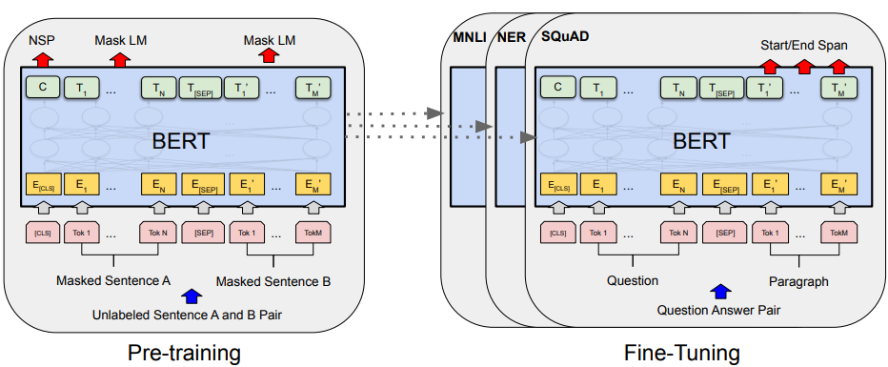

## Figure 7. Framework involves pretraining and fine-tuning

Pretraining Bert involves two tasks, MLM and NSP. In MLM, input sentences are split into input tokens. What it does is randomly mask a certain portion of the input tokens. It then proceeds to predict those masked tokens. It is worth noting that BERT only masks 15% of the input tokens to avoid a critical issue with this pre-training model; there exists a mismatch between pre-training and fine-tuning as a result of the masked tokens not appearing during fine-tuning. Meanwhile, NSP works to understand how sentences are related to one another by predicting if the next sentence is the correct one given a pair of sentences. This requires a monolingual corpus which is basically a huge collection of text in one language to be used in NLP. Although any monolingual corpus can be used, BERT makes use of the BooksCorpus which has 800 million words as well as the English Wikipedia equipped with 2,500 million words [26].

Fine-tuning BERT employs the use of a self-attention method which enables it to simulate a wide range of tasks involving ‘single text’ or ‘text pairs’. The self-attention method involves having inputs interacting with one another and producing outputs as a result of those interactions. The tasks included within fine-tuning are GLUE, SQuAD v1.1, SQuAD v2.0 and SWAG. GLUE is a set of datasets utilised in assessing, training, and analyzing NLP models with the goal of determining how well they comprehend language. SQuAD v1.1 is a database of 100,00 question/answer pairs sourced from the public. The goal is to anticipate the response text span in the paragraph from Wikipedia given a question derived from it. SQuAD v2.0 serves to extend the previous version by making sure that there is no short response in the supplied paragraph. This thus makes the problem more plausible. The SWAG dataset consists of 113,000 sentence-pair completion examples that are used to test grounded common-sense inference. The objective is to pick the most reasonable continuation from four options given a sentence [26].

### GNMT

GNMT is a neural machine translation system that uses an artificial neural network to improve text translation accuracy.

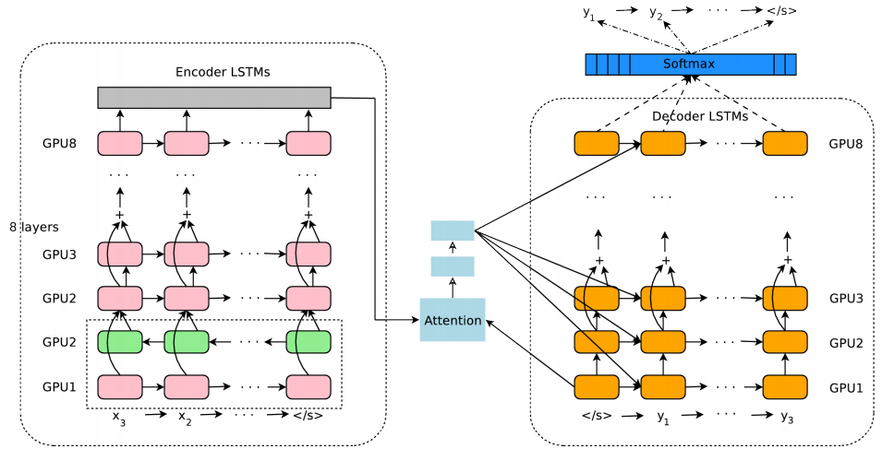

## Figure 8. GNMT’s architecture

The architecture of GNMT comprises two LSTM RNNs: an encoder network for consuming input text sequences and a decoder network for generating outputs that have been translated [26]. It is also equipped with an attention network that helps to deal with extended input sequences. From Figure 8 above, it is seen that the bottom encoder layer is bi-directional while the rest are unidirectional. The pink nodes obtain data in a left-to-right manner and the green nodes do so in the opposite direction. To enhance the training speed, the model is partitioned over many GPUs. The bottom bi-directional encoder layers compute in parallel first during training. As soon as they are done, the unidirectional encoder layers then begin computing on the individual GPUs. The RNNs are notably deep enough, allowing them to detect minor abnormalities in the target and source languages. GNMT also makes use of residual connections which are used in countering issues that arise from having very deep networks.

Addressing the problem of translating OOV words, GNMT utilises the ‘sub-word units’ approach and mixed word/character model. The word piece model, which falls under the category of sub-word units, is used by GNMT to deal with uncommon words. Initially, to process arbitrary words, they are split into word pieces using a trained word piece model. However, before training the model, special word boundary symbols are included so that the original word sequence may be retrieved without uncertainty from the word piece sequence. Through the mixed/word character model, OOV words are transformed into the sequence of their component characters. GNMT has managed to achieve a good BLEU score (a metric to evaluate predictions made by automatic machine translation systems) indicating a high level of accuracy as well as fast decoding speeds [27].

### Transformer

Transformer is a sequence transduction model that is largely utilized in NLP to address issues relating to translation. Instead of employing sequence-aligned RNNs or convolutions to solve translation problems, transformer relies exclusively on self-attention in its computations involving the inputs and outputs [28].

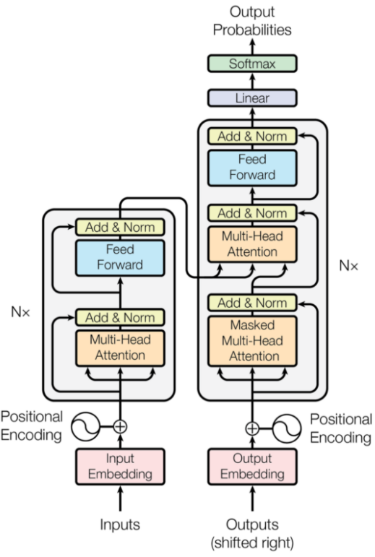

## Figure 9. Transformer Architecture

Transformer employs an encoder-decoder architecture. The encoder is made up of encoding layers that analyze the input one by one, whereas the decoder is made up of decoding layers that handle the encoder's output in the same way. The job of an encoder layer is to create encodings that include information about which sections of the inputs are related. The encodings are then sent to the following encoder layer. Meanwhile, the decoder layers take all of the encodings and produce an output sequence based on the contextual information. This is only possible via the existence of the attention mechanism used by both types of layers. Attention balances the importance of each input and takes data from them to generate outputs for those inputs. These output encodings are then passed to the next encoder as its input, as well as to the decoders [28].

### DLRM

DLRM is a personalisation and recommendation model based on neural networks. It offers two different frameworks, PyTorch and Caffe2, of which MLPerf adopts the PyTorch framework. DLRM blends 'collaborative filtering' with 'predictive analytics' to operate effectively with large amounts of data [29]. Predictive analytics uses statistical-based models to categorize or predict the likelihood of an event occurring based on the data provided, whereas collaborative filtering makes use of recommendations based on the behaviour of users.

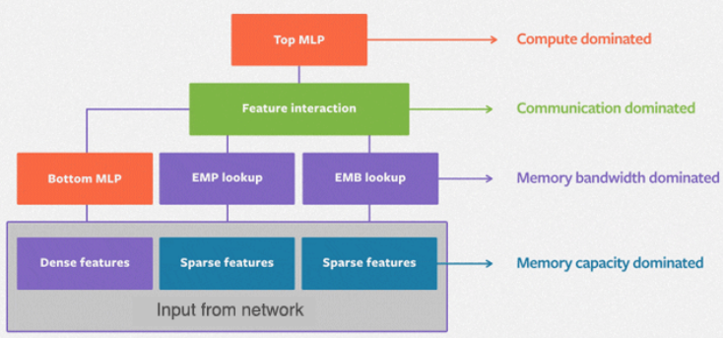

## Figure 10. The DLRM Model

To handle sparse features (also known as categorical information), the model employs the use of embeddings. With the help of those embeddings, each category is mapped to a dense representation. Meanwhile, a ‘bottom' MLP is used to handle dense or continuous features. An MLP is a feedforward artificial neural network that uses a collection of inputs to produce the corresponding collection of outputs. Following that, second-order interactions of both the dense and sparse features are computed explicitly. The resultant values are processed with a different MLP (identified as 'top' MLP) before being input into a sigmoid function, which then returns a probability [29].

DLRM seemingly leverages heavily on parallelism; specifically a mix of model and data parallelism since it comprises a significant number of parameters that can dramatically lengthen training times. Model parallelism is required to split the embeddings over the many devices with the need to overcome memory restrictions whilst data parallelism is utilised instead to further enhance the performance of MLPs within the model [29].

## HPL

HPL is a widely used benchmark that is suitable for parallel workloads that are core-limited and memory intensive. It is a portable and freely available implementation of the original HPC Linpack Benchmark. It involves solving a random dense linear system in double precision (float64) arithmetic. It is used to populate the TOP500 list, a list of the world’s most powerful supercomputers, twice a year.

The algorithm in brief has the following attributes: cyclic data distribution in matrices, lower-upper factorization using a right-looking variant with look-ahead functionality, recursive panel factorization, 6 different panel broadcasting variants, bandwidth reducing swap-broadcast and backward substitution [30]. The package also includes a testing and timing program to quantify the accuracy and time taken to achieve the solution. This makes it a good benchmark of the system’s floating-point computation power.

## Hashcat

Hashcat has a built-in benchmarking tool that calculates the hash rate on each of the cryptographic algorithms. Hashcat would provide a great benchmark in our experiment to determine the information security performance of external GPU system setups.

# EXPERIMENT SETUPS

This section will provide readers with information on different setups for the experiment.

The purpose of our experiment is to compare and analyse the performance of a multi-GPU system in different setup environments when performing AI/ML/IS tasks. In order to do this, we implement the use of multiple benchmarks across 3 different setups. There are 3 different setups mentioned in this paper, denoted as Setup A, Setup B and Setup C, which will be further elaborated in their individual sections below. The setups are conducted on the same system running on Ubuntu 20.04, with the same hardware and software specifications, which is tabulated in Table 6 and Table 7. Note that the benchmarks are first built, run and debugged on setup A before being applied to the other setups.

The experiments are also conducted in the same premise, with the setups being in an air-conditioned room. The experiments that were conducted are also designed to be as fair as possible, by attempting to have the benchmarks being conducted when the GPU is at its normal range of temperature.

#### SETUP A

Setup A involves a straightforward setup of 4 x GPU cards directly connected onto the motherboard PCIe X16. Figure 11 shows Setup A with its case detached for this particular image. The experiments that were conducted in this project were done with the case sealed. The normal range of temperature for this setup is.

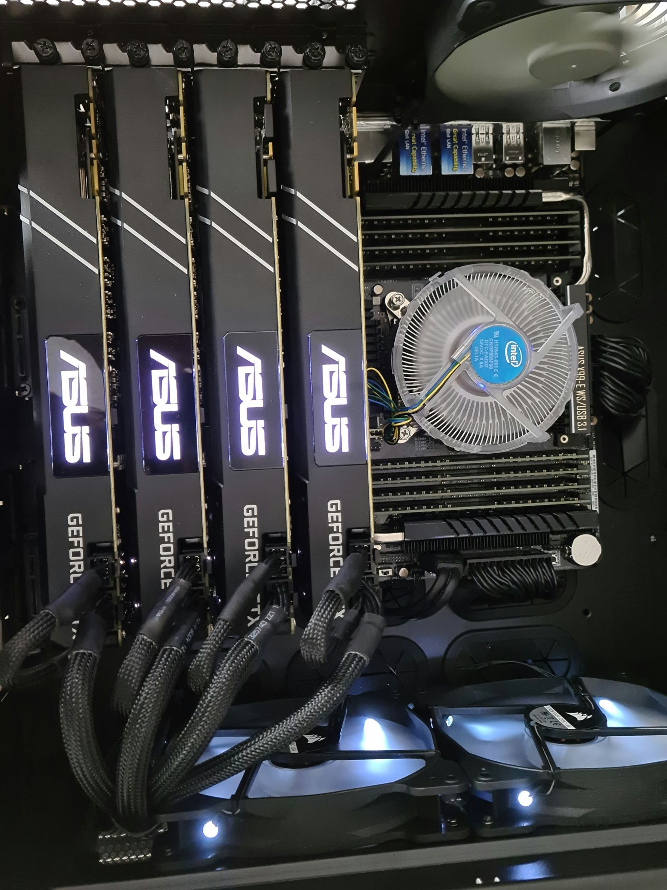

## Figure 11. Setup A

#### SETUP B

Setup B involves connecting a PCIe Switch extending to 4 x GPU cards on riser cards using a USB cable as depicted in Figure 12. In the figure below, the case is detached for better visual representation. During the experiments, the case will be closed to the best of its capabilities. The normal range of temperature for this setup is.

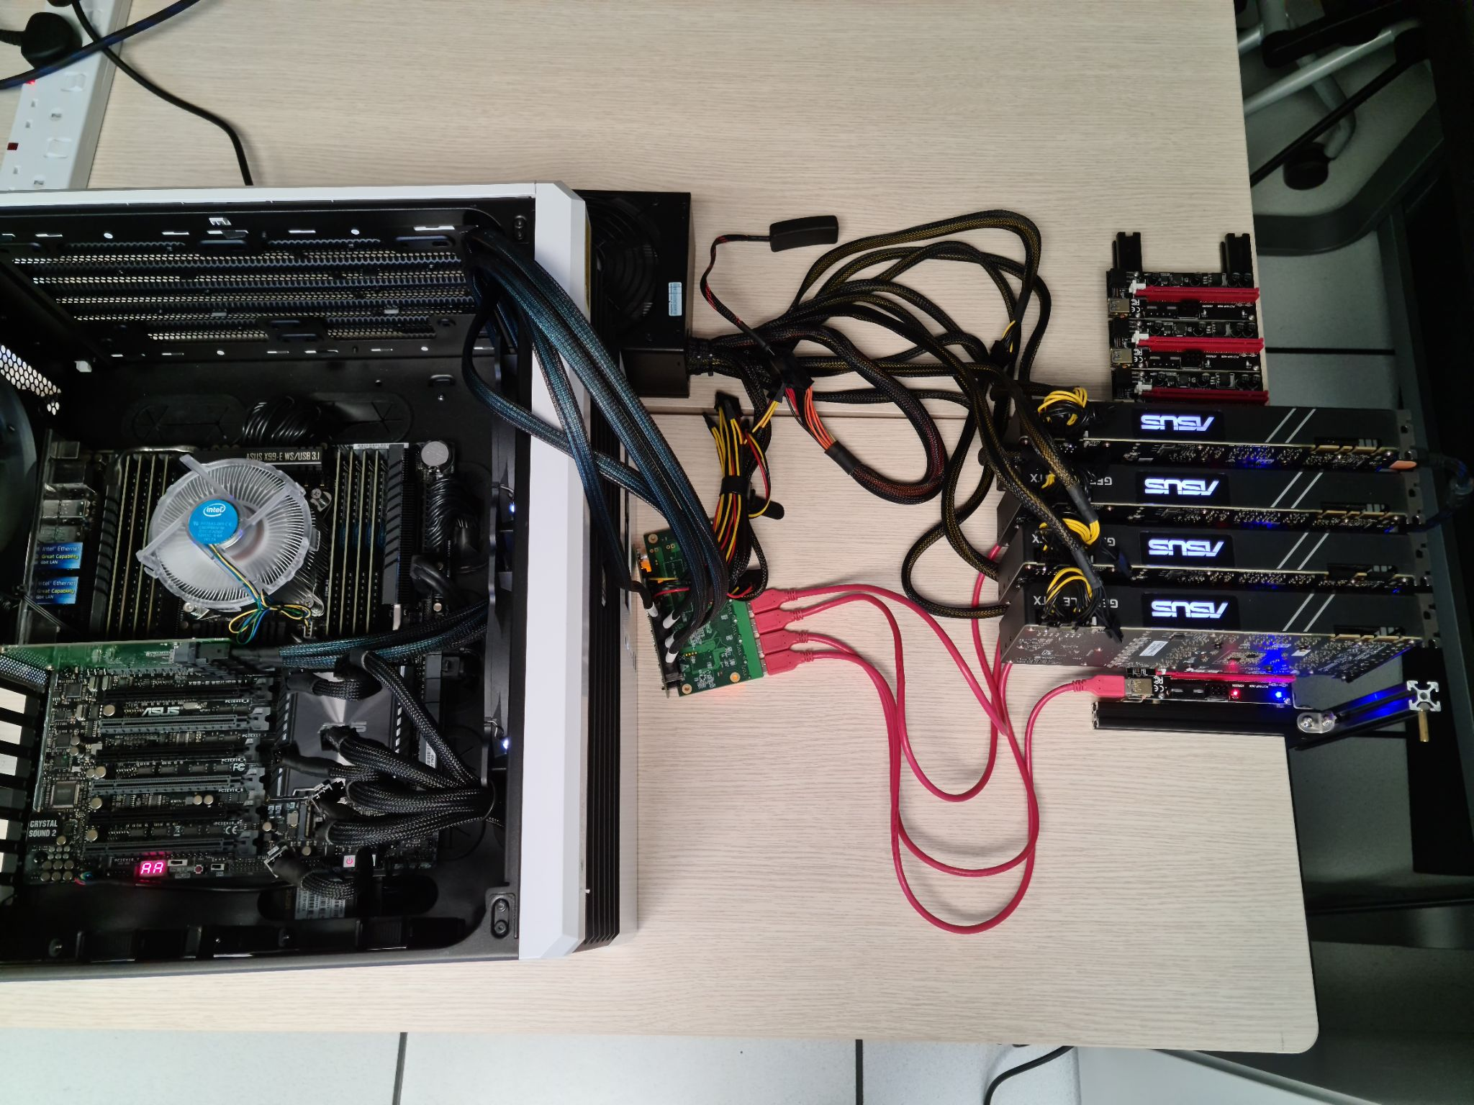

## Figure 12. Setup B

#### Specifications of the PCIe Switch

The PCIe switch we used utilises a PLX Technology PEX 8614 chip. The port configuration for our switch is a PCIe 4x to 8 PCIe 1x in a fan-out topology. It has a reported maximum latency of 140 ns in this configuration. The switch uses a non-blocking internal switch architecture and has guaranteed error-free packets. It also has a max payload size of 2048 bytes and has an integrated 5 Giga Transmission per second(GT/s) Serializer/Deserializer(SerDes). Each port has auto-negotiation, lane reversal and polarity reversal. Lastly, it has a low power draw of only 1.74W. Below is a visualization of the switch’s port configuration.

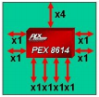

## Figure 13. PCIe Switch Port Configuration [31]

#### SETUP C

Setup C involves 4 x GPU cards onto riser cards

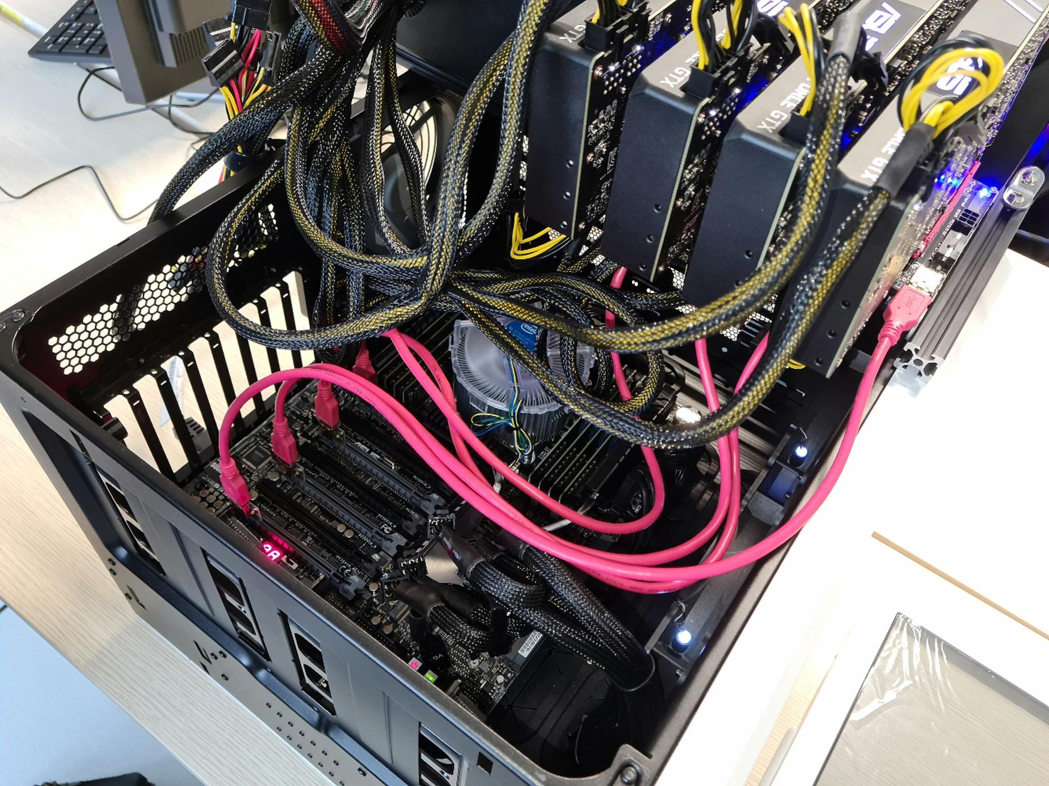

## Figure 14. Setup C

# BENCHMARK SETUPS

This section will provide readers with information on how the benchmarks are being set up to run on our machines for the experiment.

## Hashcat

For our project, we used Hashcat V5.1.0. In order to benchmark our system, we ran hashcat with the ‘-b’ flag.

## HPL

The original source code for NVIDIA’s CUDA accelerated HPL can be retrieved here [32].

For our setup, we had to modify certain parts of the source code to get the benchmark to compile and run. As OpenMPI has deprecated and replaced functions like ‘MPI_Address’ with ‘MPI_Get_address’ and ‘MPI_Type_struct’ with ‘MPI_Type_create_struct’, we had to replace these functions to get it running.

The HPL.dat file has variables that can be tuned so as to perform better (produce higher GFLOPs). The main variables which impact the performance are as follows [33]:

* N: Indicates the problem size to execute
* NB: Indicates the block size to run
* P: Number of process rows. (P x Q) should equal to the number of processes that your system has
* Q: Number of process columns. (P x Q) should equal to the number of processes that your system has

The purpose of our experiment is to compare the results of the performance from different environment setups. Hence, we will not be looking at changing the variables to achieve the highest possible performance for each setup, but instead to define a comfortable and realistic baseline with which to compare the environment setups.

We will be keeping the configuration static across all our setups to have a fair comparison. Figure 15 illustrates our configuration for the HPL.dat file.

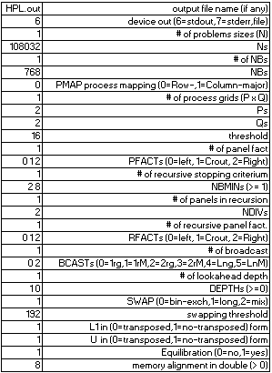

## Figure 15. HPL.dat config

As seen in the figure, we set N as 108032 and NB as 768. The values of P and Q are both set as 2, denoting the 4 processes the system can offer (1 process per GPU).

## MLPerf

MLPerf consists of multiple modules, where each module will run on its own dockerized container. The individual benchmark information and the corresponding steps to run them can be found on their Github repository [34]. The steps have been modified with respect to our system specification and its associated commands are included for reference. The benchmarks that are run are all training benchmarks. Note that there are different versions of the training benchmarks (v0.7, v1.0) which come with different git repositories and they have been included in the individual sub-sections below. An installation guide for each MLPerf module has been included in the Appendix, as well as in our Github repository, as a reference if anyone wishes to replicate the experiment.

### Benchmarks excluded

After the completion of the setup for the MLPerf benchmark modules, the team has found out that there will not be enough time to complete the full benchmarks for all 3 setups with the full MLPerf suite. While performing trial runs on the modules that were successfully installed, one of the modules - M-RCNN has an estimated completion time of 3 days, as shown in a snippet in Figure 16.

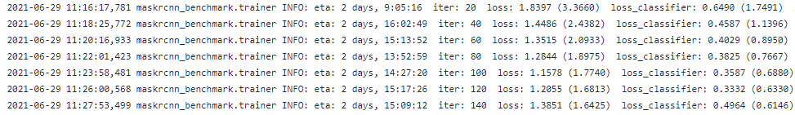

## Figure 16. M-RCNN run snippet

As the benchmark has just started and the estimated time to completion is still fluctuating, the team decided to let the run continue through the night and check the progress for the benchmark the next day. The benchmark ran for approximately 16 hours, where the estimated time to completion was at 2 days as shown in Figure 17. For reference, the full run for M-RCNN till this point can also be found inside the Github Repository



## Figure 17. M-RCNN run snippet 2

This difference in timing has changed the outlook of the team on MLPerf. The estimated completion time for running MLPerf on NVIDIA’s setup on their blog post [35]. The team did not take enough consideration in the differences in setups and has incorrectly gauged the time required to complete MLPerf. This led the team to think that it is impractical to run this particular module, as there would not be enough time to complete the research at this pace.

Given that the team has to conduct 3 setups, this particular module requires a minimum of 5 runs and each run takes approximately 3 days to complete per run. It would take the team 45 days to complete this benchmark alone. As time is limited, the team has decided to go with 2 of the MLPerf modules that would fit into the team’s schedule - SSD and ResNet.

# EXPERIMENT RESULTS

This section will provide readers with the results of the experiment that was discussed in the previous section.

## Hashcat

The Hashcat benchmark is run when the GPUs are at normal temperatures. The results for Hashcat is the number of hashes that can be generated at a fixed amount of time for a particular algorithm. This benchmark is performed with only Hashcat running in the background, and runs a total of 10 times to ensure consistency of the data gathered.

The comparison of the different setups can be seen in the scatter plot from Figure 33.

#### Setup A

A snippet of the Hashcat results for Setup A can be found in Table 10. A full spreadsheet of the Hashcat results can be found in Appendix B, with the full details of each individual run. The raw output for the benchmark can be found on our Github repository.

The overall results for Hashcat in Setup A over the 10 iterations were generally consistent. A small snippet of hashes generated sorted by hash type can be seen in Figure 18, where it shows the hashes for the particular hash type across 10 iterations.

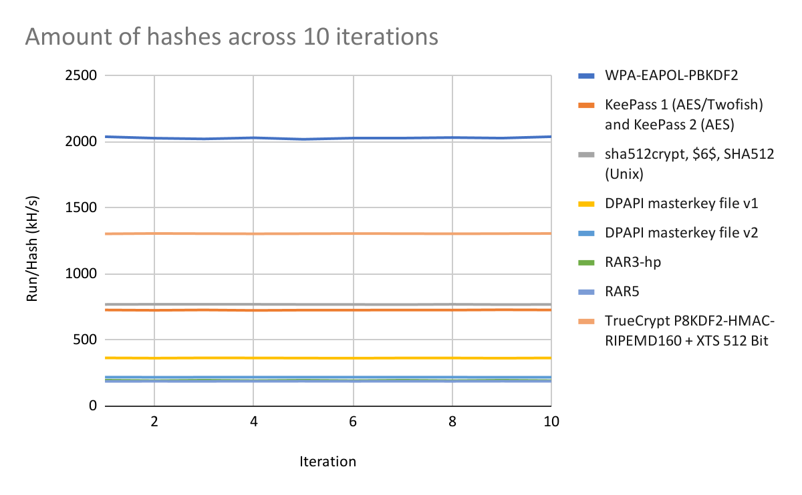

## Figure 18. Setup A hashes across iterations

#### Setup B

A snippet of the Hashcat Results for Setup B can be found in Table 11. A full spreadsheet of the Hashcat results can be found in Appendix B, with the full details of each individual run. The raw output for the benchmark can be found on our Github repository.

A snippet of a general overview of the hashes done over the 10 iterations for Setup B can be found in Figure 19.

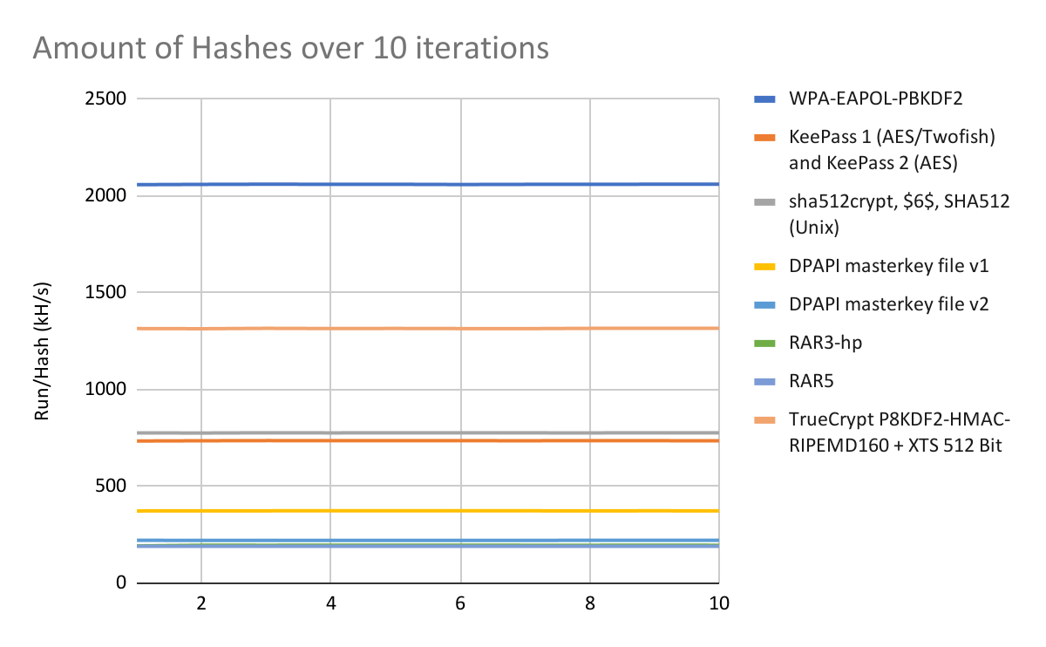

## Figure 19. Setup B hashes across iterations

#### Setup C

A snippet of the Hashcat Results for Setup C can be found in Table 12. A full spreadsheet of the Hashcat results can be found in Appendix B, with the full details of each individual run. The raw output for the benchmark can be found on our Github repository.

A snippet of a general overview of hashes done over the 10 iterations for Setup C can be found in Figure 20.

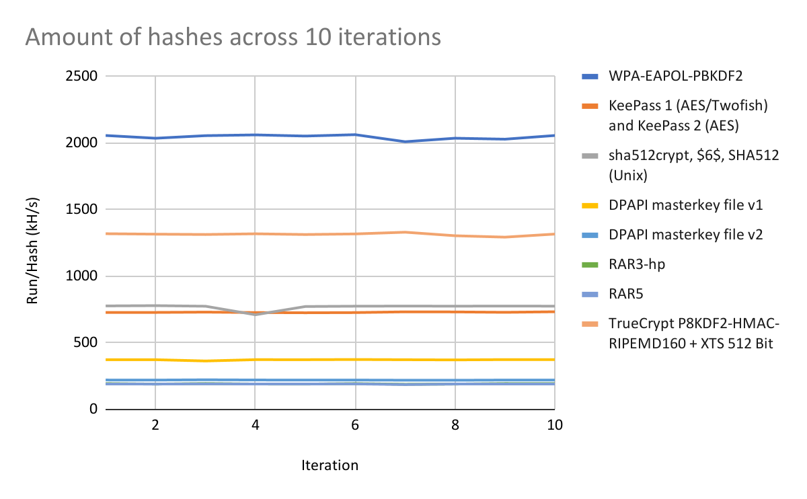

## Figure 20. Setup C hashes across iterations

Compared to the other 2 Setups, the results fluctuate more and are not as consistent as the other two setups. The team has tried to re-run to simulate this result but the results were similar. Hashcat benchmark consists of 25 different hashes, and the fluctuations can be seen on at least 16 of the hashes.

## HPL

The xHPL benchmark is run when the GPUs are at normal temperatures. There is no recommended number of runs, so our team decided on 10 runs per setup.

#### Setup A

Setup A achieved an average of 1,126.20 GFLOPs / 1.126 TFLOPs, with most of the runs yielding relatively close results. The standard deviation of the entire set of results is 9.94 GFLOPs, a 0.88% deviation from the mean.

#### Setup B

Setup B was unable to run the same benchmark as the other 2 setups. The test environment would freeze up and only a hard reset would fix it. We could only get it to run with a maximum N size of 16384, whereas the other setups could run an N problem size of 108032. Thus, we had to remove it from our comparison, as N size represents the difficulty of the problem the system has to solve.

### Setup C

Setup C achieved an average of 233.25 GFLOPs. The difference between runs fluctuates a fair bit, with a standard deviation of 33.4 GFLOPs, a 14.32% deviation from the mean. . However, after calculating the interquartile range and checking for outliers, all the results we recorded are valid and there are no outliers. Below is a comparison chart between setup A & C Figure 21.

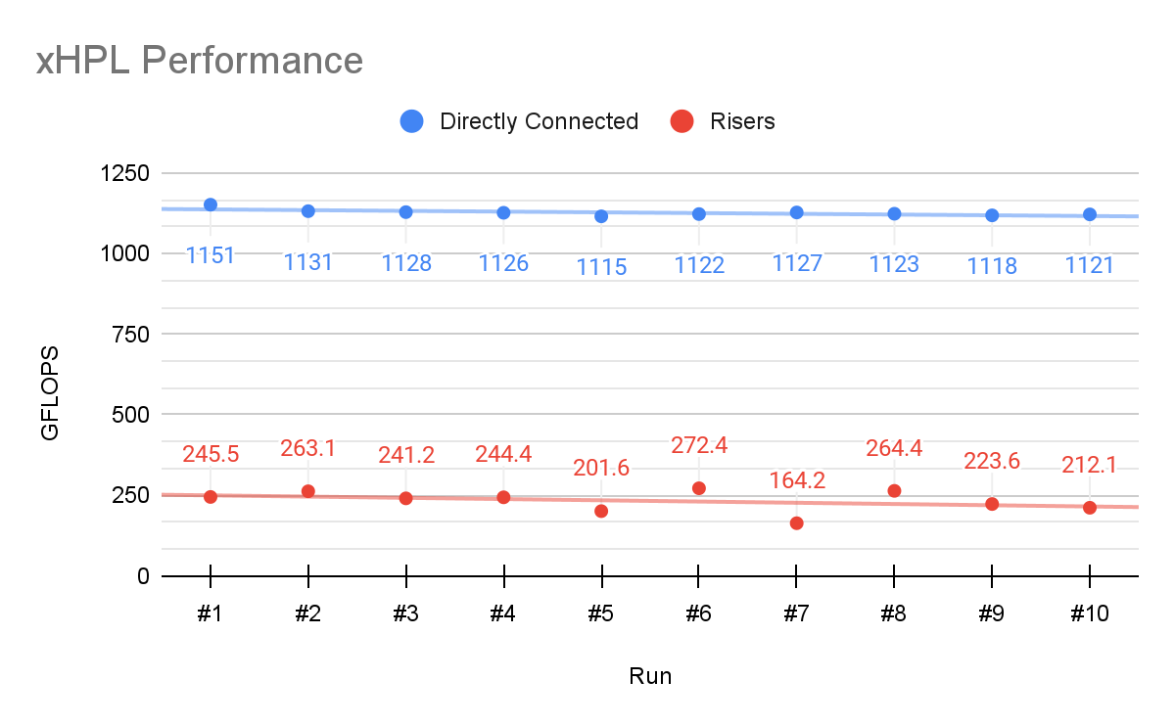

## Figure 21. Comparison between Setup A & C for HPL

## MLPerf

The MLPerf modules are run when the GPUs are at normal temperatures. MLPerf has a fixed number of runs for their benchmark specified within their configurations inside their Github repository. The two modules that the team will be using will be SSD and ResNet.

#### SSD

The goal of the SSD module in MLPerf’s benchmark is to train the neural model from a clean slate to a certain degree of accuracy. The model makes use of the COCO dataset (preprocessed to a fixed size) and categories specified to compute boundary boxes that may contain objects before categorizing them. A mean Average Precision(mAP) will then be generated after every 5 epochs, where the model will keep training until the specified target of 0.23 mAp is achieved.

#### Setup A

In Setup A, the iterations that the team has conducted are similar in general, with most runs having a similar flow of mAp gains and losses as shown in Figure 22. A normal run would take approximately 54 epochs and 10 hours as tabulated in Table 8. Time taken per epoch was also quite consistent, with an average of 11 minutes and 2 seconds per epoch with a standard deviation of 3 seconds. This data is tabulated with other results in Table 8.

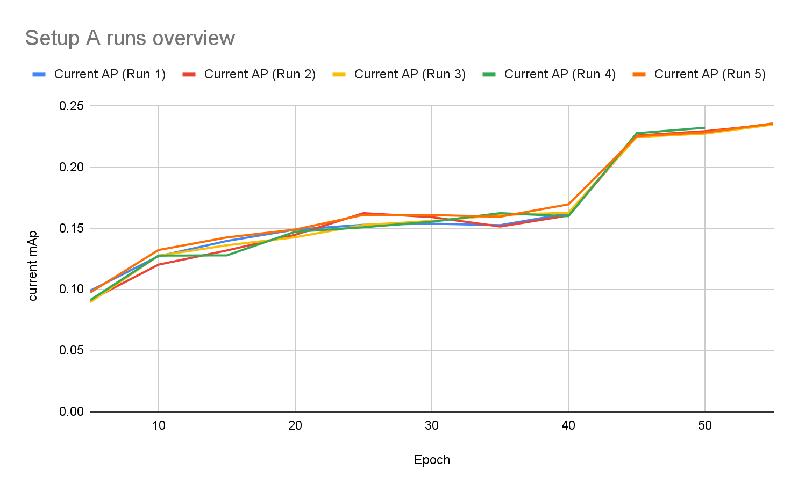

## Figure 22. Setup A overview of runs and AP gains over epochs

#### Setup B

Setup B has had similar learning curves with reference to Setup A. The 5 runs for Setup B were consistent, with an average of 53 epochs and approximately 14:59 minutes for each epoch. The overview of each run is shown in Figure 23 and the overall results for Setup B are tabulated in Table 9.

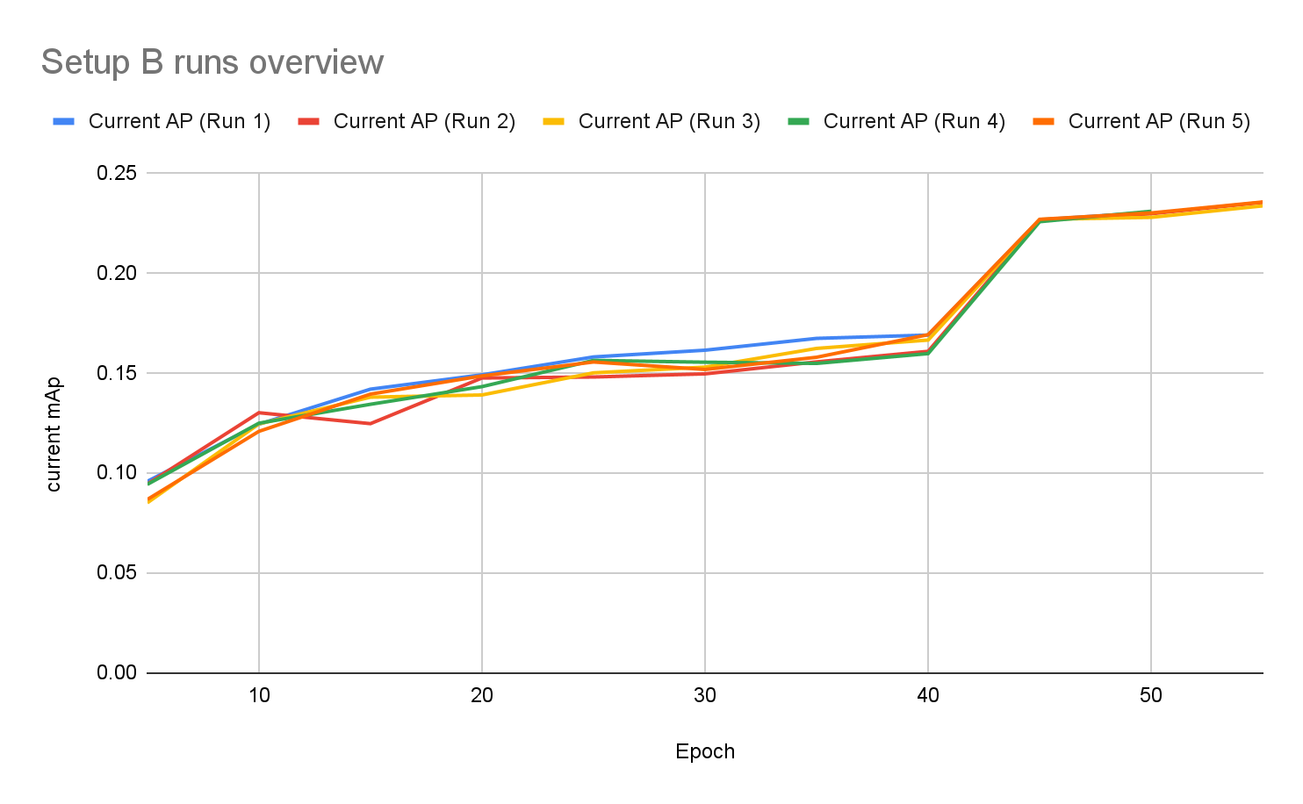

## Figure 23. Setup B overview of runs and AP gains over epochs

### Setup C

Setup C had problems completing the full SSD module benchmark. Out of the 10 runs that the team has done for this setup, 1 run was successfully completed, whereas the rest of the runs crashed during the run. The single run that was completed was documented, and the run should be taken into consideration that the runs were generally inconsistent. The inference that the team had based on this issue can be found in Section 12.

#### ResNet

The Resnet module in MLPerf’s benchmark calculates the training and inference performance using throughput (images/second) as a metric, and the number of epochs required to hit a top1 accuracy of 75.9% when training the model. We are using the ResNet-50 v1.5 model with MxNet in our experimentation. The average time taken to complete training the model is > 72hrs. A total of 90 epochs are scheduled to run, and each epoch requires 30min to complete. Running multiple times for training models is too time-consuming, and as such we will not be using the elapsed time or epoch number as a metric for performance and use throughput as our metric for training and inference performance. The benchmark module also uses the ImageNet1k dataset which consists of 1000 object classes containing a total of 1.2m training images and 50000 validation images. In our experimentation, the benchmark was run 3 times, with 3 epochs each, and 500 iterations per epoch. The parameters were used for all 3 of the setup to ensure consistency

#### Setup A

Setup A achieves an IPS of 584 and 1732 for train and validation respectively and elapsed time of 22 min 2sec and 8 min 9sec for train and validation respectively. The full benchmark results can be found in Table 15.

#### Setup B

Setup A achieves an IPS of 457 and 1065 for train and validation respectively and elapsed time of 28min 31sec and 12 min 38sec for train and validation respectively. The full benchmark results can be found in Table 16.

#### Setup C

Setup A achieves an IPS of 218 and 1165 for train and validation respectively and elapsed time of 57min 15sec and 11 min 34 sec for train and validation respectively. The full benchmark results can be found in Table 17.

# EXPERIMENT COMPARISONS

This section will provide readers with the comparisons of the results obtained in the previous section between the different setups.

## Hashcat

### General Comparison

A table of results compiled together with the average hashes generated over 10 runs can be found in table 13. Regarding that table, Setup B had the best results for 76% of the hashes done in the Hashcat benchmark. Following that, Setup C with 20% and Setup A did the best for 4% of the hashes.

Following the results, it is safe for the team to deduce that Setup B has the best performance in the cracking of hashes. The main issue would then be, why would Setup B excel better in this field as compared to Setup A or Setup C. The main differences between the setups would be the hardware involved, as well as the temperature in which the setup is conducted. Thus, there are three main learning points in which the team has extracted out from this experiment - Algorithm, Temperature and Hardware.

### Algorithm

As evident from the table mentioned, it is clear that one of the setups performs significantly better than others. However, if one of the setups performs better than the other in different ways and is not consistent throughout the different hash algorithms, the team feels that algorithms play a part in affecting the results that are present.

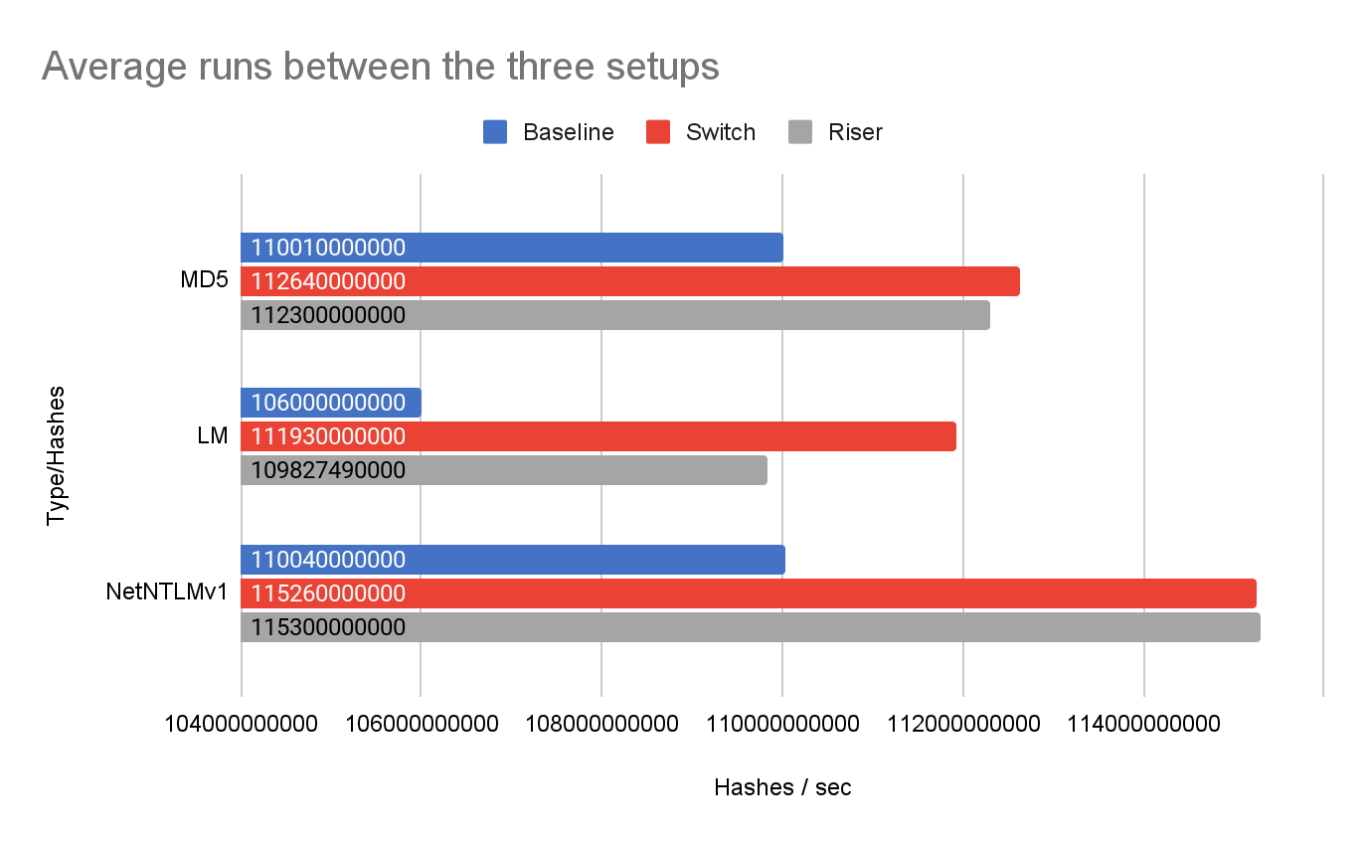

## Figure 24. Results from Hashcat between the three setups

Figure 24 shows the inconsistencies of the results in terms of hashes generated. The results do not show a consistent state of a setup is better than the other, but more of a mix between the two, there are instances in which one setup is better than the other in different scenarios.

The main reason why the industry uses GPUs to crack hashes is parallelism. However, due to the nature of an algorithm, different setups will obtain optimal results. If the result is based on a simple hash algorithm, for example, LM. As the algorithm is simple, the complexity shrinks and the GPU efficiently makes use of its cores to optimise the processes. Newer algorithms, such as Litecoin’s encryption, make use of Scrypt, which is a form of key-derivation function. Scrypt is memory intensive and will have an impact on different setups. This is just one of the many algorithms out there that exist that will cause different results through the different setups.

### Temperature

Another factor that the team has noted that was vastly different would be the difference in temperatures in which the GPUs are operating throughout the run. Setups B and C had relatively similar temperatures as compared to Setup A. The results, in general, are also skewed towards Setups B and C have similar results, as compared to Setup A. The temperature log for each setup can be found in the Github repository. alongside their thermal limits as a reference for this experiment.

Thus, this led to the team thinking that temperature could be one of the major factors to the number of hashes one setup might be able to generate. As such, the team decided to find a way to allow the GPU to run at a lower temperature as compared to Setup A. By running the fan from within the GPUs, it is possible to cool the GPU and run tasks at the same time. The room temperature for this new setup is about 46 Degrees as compared to the initial 55 Degrees.

The results have been recorded and can be seen in Table 14 in the appendix, where this new setup is compared against the initial 3 setups. The new setup has improved when compared with Setup A after the reduction in temperature and has the best performance 92% of the time throughout the benchmark. Another graph, Figure 30 shows Setup A and its counterpart with better cooling. With a difference of just 9 Degrees, there are increments through the different hashes in the Hashcat benchmark ranging from 9.7% to 2.4%. Temperature plays a part in how a GPU behaves and will be further elaborated in detail under section 12.5.

### Hardware

Hardware differences could also potentially be a factor that affects the performance of Hash generation. Each Setup has a different way of connecting to the GPU. Setup A directly through the motherboard, Setup B through PCIe switches and Setup C through the use of PCIe Riser cards.

There have been multiple experiments done with GPUs connected via Riser cards against a directly connected GPU to the motherboard in other fields. The results have shown that the differences between the two are very minuscule, which one could argue, almost similar to the results that the team has obtained.

The findings of the experiment were that cables induce latency, which was the main reason why the two setups have no differences at all. This could be seen if we compare Setup A when it was being cooled, and Setup C. The new Setup A, with a similar GPU temperature as Setup C, performed slightly better than Setup C.

The second finding that the team had was that the way the hardware is connected could affect the performance of hash generation as well. This becomes evident in Setup B, which involves connecting a switch via one PCIe slot on the motherboard, then branching out to the 4 different GPUs having a better result with 4 GPUs connected to 4 different PCIe slots on the motherboard. The team looked more into this, and more information can be found in section 12.6.

## HPL

Setup B was unable to successfully run the benchmark. We have a theory that the PCIe switch was being overwhelmed by the amount of bandwidth, as the same test was able to run on Setup C, but we do not have a conclusive way of testing it. Our reason for the theory is that both Setup B and C run on PCIe 3.0 1x electrically, so there is no difference in effective bandwidth, thus the difference is either in the switch or in the chipset. The southbridge was able to distribute the data to all the cards effectively, as we can observe in Setup A & C, therefore the switch should be the cause of the problem.

Setup C overall performed 79.29% worse than our baseline Setup A, with an average difference of 892.95 GFLOPs. This is a huge difference in performance and it is caused by the difference in available bandwidth.

## SSD

### Bandwidth Bottleneck

It is clear from the results that there could be a potential bottleneck in terms of bandwidth for Setups B and C. The team observed that the performance of Setup A greatly surpasses Setup B by 36.01% and Setup C by 125.52%. A graphical representation of this can be seen in Figure 25, where the graph shows the time taken per epoch, which is approximately 900 iterations per epoch.

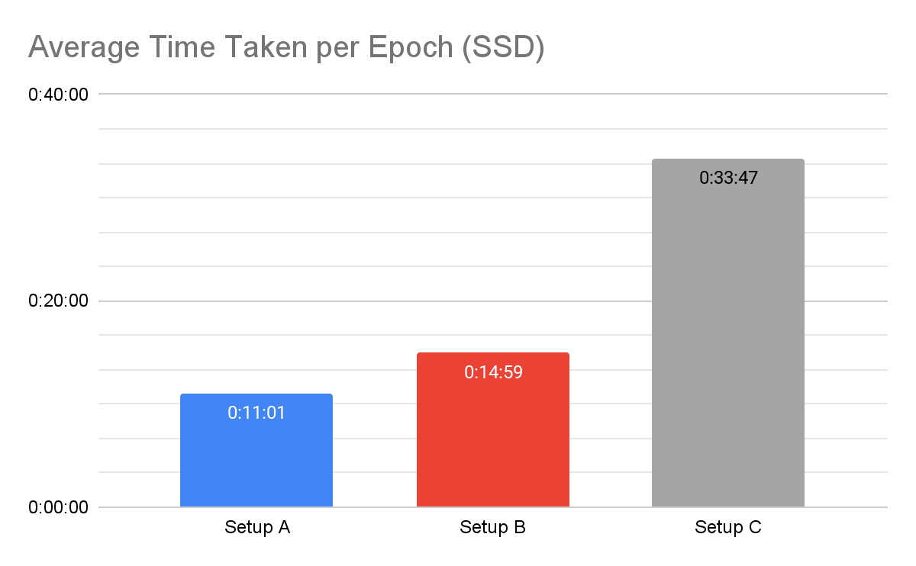

## Figure 25. Average time taken per epoch for SSD

The three setups are all connected through a PCIe Gen3.0, however, the connectors that they are connected to are different. Setup A is connected directly through an x16 PCIe slot, whereas Setup B is connected via a switch through an x4 connector, Setup C on the other hand is connected through an x1 slot individually per GPU. The differences in data lanes could allow the setup with more data lanes to have a higher bandwidth as compared to the other setups (also dependent on PCIe protocol).

### Inconsistencies of Hardware

Through the experiments, it became a norm that Setup C is the most inconsistent setup across all benchmarks, with standard deviations being the highest across all three setups. This can be most clearly seen from the Hashcat results, where the results across all 10 runs were considerably more inconsistent as compared to the other two setups. The benchmark test for this module has also crashed for Setup C, whereas Setups A and B were successful in their runs of the benchmark.

One of the theories that the team had was that the inconsistency of the data that is being sent out by the risers caused errors somewhere between the runs, causing the benchmark to crash prematurely. This module in MLPerf would be considered a more strenuous test as compared to the other benchmarks due to the time taken to complete a single run. Other tests such as Hashcat as well as ResNet or even HPL do not take as much time to complete when compared to this module. The team does not have a valid explanation as to why the program crashed due to the lack of hardware available to perform additional analysis. The reason behind the crashing of the benchmark could be caused by the lack of bandwidth, which could be tested with other types of riser cards (an x8 connector or even an x16 as compared to an x1).

## Resnet

### Bandwidth Bottleneck

We observed a great difference in performance compared to the results in Hashcat. In resnet50, We observed that the performance of setup A was overall better than setup B and C by a significant amount. This was within expectation as resnet50 requires a lot more memory to perform data loading and pre-processing of images using GPU. The results show that there is a performance drop in throughput and latency of more than 20% for Setup B and C. In setup A, the GPUs are slotted directly to the X16 PCIe Gen3.0 slots (16GB/s). In setup B, the PEX8614 chipset specification has an upstream speed equivalent to X4 PCIe Gen3.0 (4GB/s), and a downstream speed of X1 PCIe Gen3.0 (985MB/s). In setup C, the GPUs are slotted in X1 PCIe Gen3.0(985MB/s). The bandwidth in both setup B and C is significantly lower than Setup A. The results support that a bottleneck has occurred in the PCIe Switch and the riser setup is due to lower bandwidth.

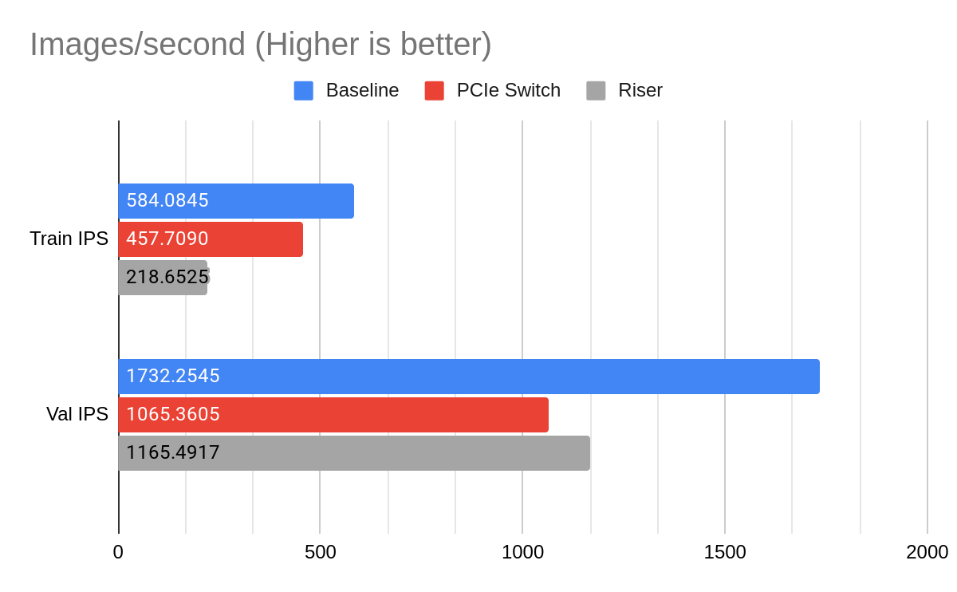

## Figure 26. Resnet50 throughput results

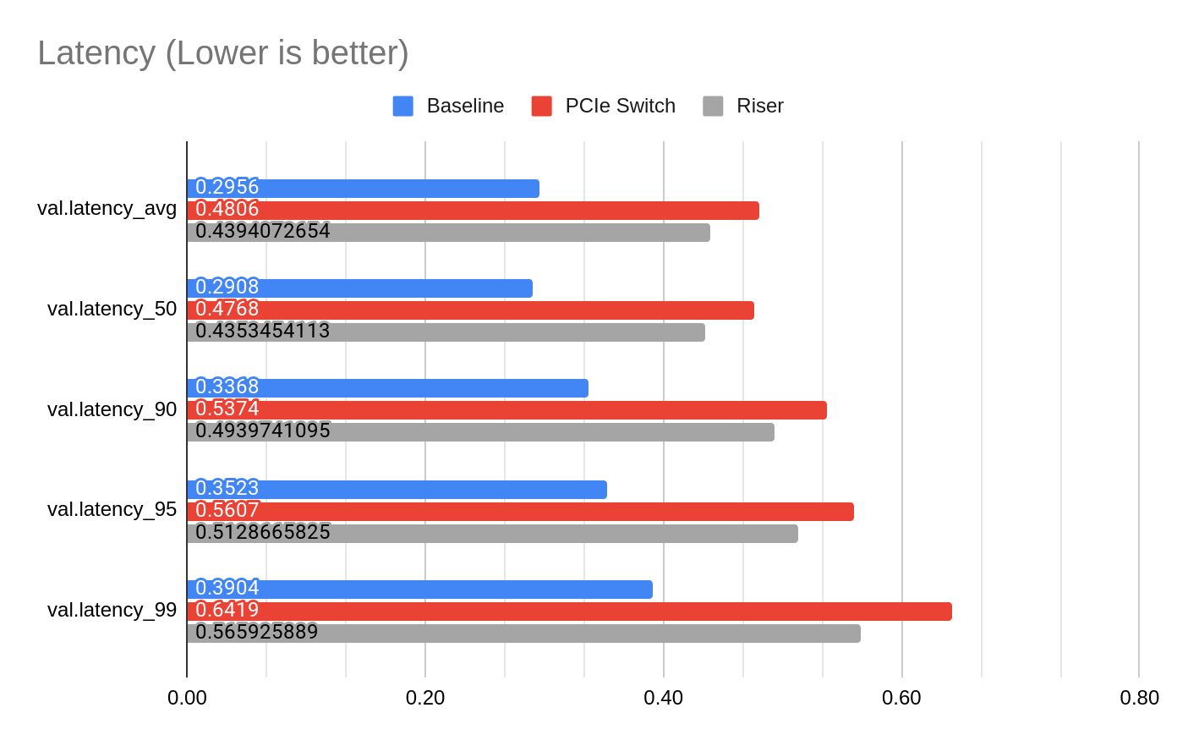

## Figure 27. Resnet50 Validation Latency

### Data Augmentation

However, we also observed that the training performance of setup B is better than setup C, yet the validation performance of setup B is slightly lower than setup C. This was an interesting finding as it was not within our expectations. After researching for the cause of irregularity, we identified that this is due to the data augmentation performed during preprocessing in the benchmark.

Resnet50 has two preprocessing pipelines, one for training and one for validation. The training preprocessing pipeline includes 7 data operations which are: Read a raw image, Decode, Resize, Random Crop, Random horizontal flip, Transpose, Normalise. The validation preprocessing pipeline is similar to the training pipeline with the Random crop operation as the only exception; Random crop is not performed during validation.

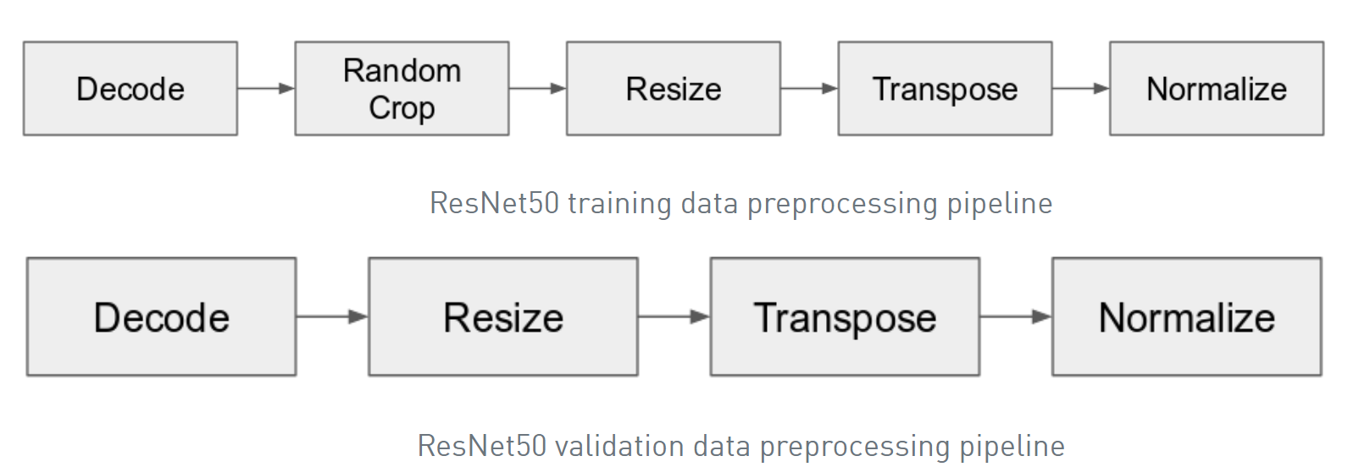

## Figure 28. Resnet50 Preprocessing Pipelines [36]

Data augmentation increases the amount of data and reduces overfitting of models. A reduction of one operation in data augmentation would result in faster preprocessing. This means that validation throughput would usually be higher than the training throughput. In this benchmark the data augmentation used for training are: Normalization, Random Resize and crop to 224x224, 8% to 100% scaling, Aspect ratio from 3/4 to 4/3, Random horizontal flip. The data augmentation used for validation are: Normalization, Scaling to 256x256, Center crop to 224x224 [37].

The training benchmark requires a large amount of data and preprocessing compared to validation. The reduced preprocessing operations during validation allows Setup C to perform better. The drastic performance improvement goes to show that Setup C was previously bottlenecked by the preprocessing operation in training which involves greater bandwidth than validation.

## GPU Boost 3.0

We observed that hashcat performance on the baseline was worse than the PCIe switch, which was very unexpected. To ensure our experiment was not flawed, we had to find out why that was the case. After some observations, we noticed that the temperature of the GPUs was higher in the baseline, highest was ~85°C and lowest was ~79°C, compared to the PCIe switch, highest was ~79°C and lowest was ~55°C. We theorized that the case was limiting the airflow to the GPUs, causing the temperatures to climb much more quickly compared to the PCIe switch setup, which has unrestricted access to fresh air.

Temperature plays a huge part in GPU performance, due to NVIDIA’s method of dynamically boosting clock speeds until the cards hit the power or temperature limits. This allows the GPUs to boost much higher than the advertised boost clocks. For the cards we are using, the boost clock is advertised at 1582MHz, and under sufficient cooling, we observed a core clock of about 1822MHz. This number fluctuates quite a bit as the boosting algorithm makes split-second changes to a large number of parameters to keep the GPU at the maximum possible boost frequencies. In GPU Boost 3.0, the target temperature is set to 80°C, which lines up with our observed temperature in the PCIe switch setup.

GPU Boost has multiple conditions to provide the highest possible boost clocks, namely: power headroom, voltage, thermal headroom, boost binning, and thermal throttling [38].

### Power Headroom

GPU boost will automatically overclock the card if there is enough power headroom available to achieve higher boost clocks, thus enough power must be supplied to the cards so GPU boost can work as intended. It is also the most common limiting factor as the card will use up all the available power to hit higher clocks.

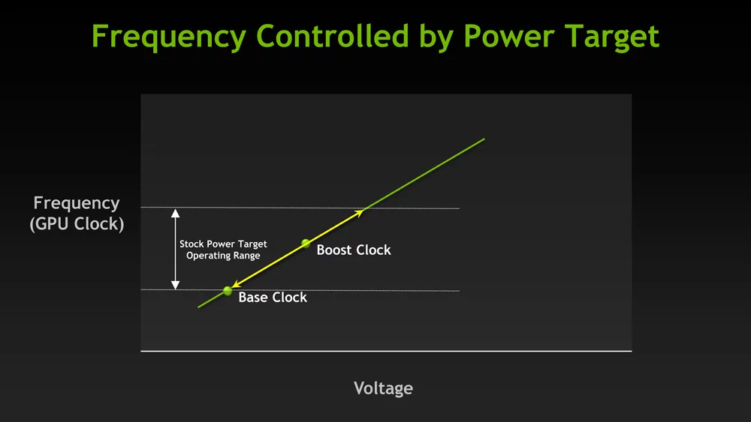

## Figure 29. GPU boost can depend heavily on power limits

Power limit was not a concern for our setups as the maximum power draw of each of our 1080 Ti is 250W, and we have a 1600W PSU.

### Voltage

The GPU’s power delivery system needs to be able to provide the additional voltage that is needed to hit and sustain the higher clock speeds. Voltage is a direct contributor to temperature as well so it ties into the thermal headroom condition as well. There is a hard limit to how much voltage the card can use and that limit is set by the card’s BIOS, usually around 1.0V+-. GPU Boost takes advantage of any voltage headroom to try and sustain the highest clock speed it possibly can.

### Thermal Headroom

Thermal Headroom is the third major condition that has to be fulfilled to get effective operation of GPU boost. The boosting algorithm is extremely sensitive to the temperature of the GPU and will increase or decrease the clock speed based on the slightest change in temperature, thus the need of keeping the temperature of the cards as low as possible to achieve the highest clock speeds. Temperatures higher than 75°C will cause the clock speed to drop noticeably. Even though the clock speeds will still be higher than the advertised boost clocks, it’s not desirable to leave performance on the table. Our cards often drop clock speeds to keep the temperature in check, especially in the baseline setup where the temperature is high.

### Boost Binning

GPU boost changes the clock speeds depending on all the above-mentioned factors in blocks of 15MHz. One block of 15MHz is known as a boost bin. It can be observed that the clock speeds only move in blocks of 15MHz, although it can drop multiple bins at a time.

### Thermal Throttling

Pascal architecture cards and later like the 1080Ti we are using in the experiments usually do not undergo thermal throttling (TT). The cards only start to thermal throttle at a fixed temperature known as Junction Temperature Max (TJMax). For our card, that temperature would be 93°C. When the card reaches this temperature, the clock speeds will gradually drop until it falls below the base clock or until the temperature is below TJMax. The reason Pascal cards and later do not usually thermal throttle is due to GPU boost, which regulates the temperature by increasing and decreasing the clock speeds through boost binning to hit the target 80°C.

The main difference between TT and boost binning is that boost binning alters the maximum clock speed achieved by GPU boost using temperature data, while TT occurs at or below the base clock. As our cards do not hit TJMax, the highest observed was 89°C during ResNet50 training, we do not undergo TT, instead, we are dropping boost bins.

To confirm our theory that temperature was causing the drop in performance in the baseline setup and not some other factor that we missed, we ran 10 runs of hashcat with the fan speed manually set to the maximum. The results are quite conclusive.

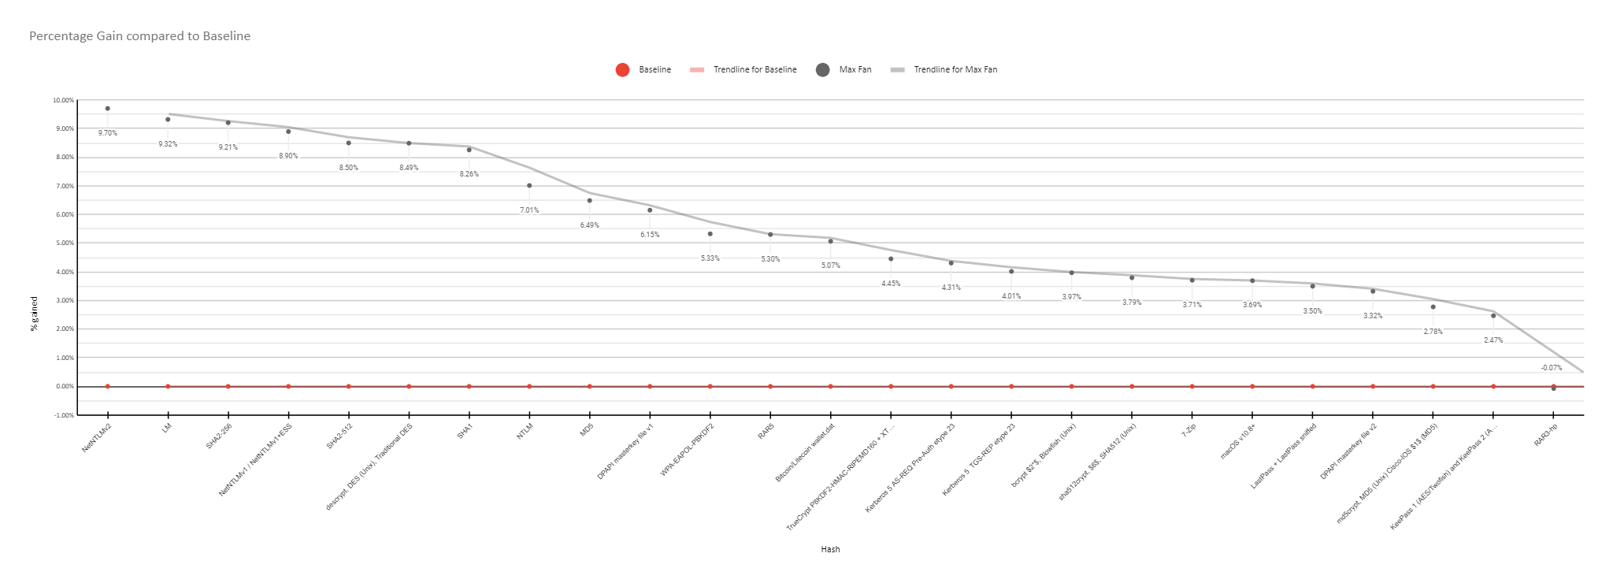

## Figure 30. Percentage gain compared to baseline

## PCIe Switching

We observed that the performance of setup B was overall better than setup C in hashcat. This came off as odd as there were more components that data had to pass through, thus we expected the PCIe switch to perform worse than the riser cables. After further research, we figured out why this was the case.

In Setup C, each card has its dedicated slot on the motherboard, whereas in Setup B, all the cards are connected to the first slot in the motherboard through the PCIe switch.

#### How PCIe lanes are controlled

There are multiple PCIe slots on a motherboard, but only the top-most one is controlled directly by the northbridge or host bridge. Historically, the northbridge was a separate chip connected to the CPU via a high-speed interface called the system bus or front-side bus (FSB). The northbridge controls the performance-critical components like the RAM and first PCIe slot [39], usually dedicated to the graphics card. Nowadays, the northbridge is integrated on the CPU [40].

The other PCIe slots, also known as PCIe expansion slots, are controlled by the southbridge. The northbridge and the southbridge are the two chips that make up the chipset that we know of. The southbridge mainly implements the slower capabilities of the motherboard, like the BIOS, USB, PCIe expansion slots and others. The southbridge is connected via the northbridge, hence the other PCIe slots are usually slower than the first slot [41].

#### Why this is relevant to us

By moving the cards from the PCIe expansion slots to the switch, we are also moving the cards from the southbridge’s control to the northbridge and the PCIe switch’s control. This might have caused the difference in performance between setup B and C, even though all the cards are effectively connected via PCIe3.0 1x in both cases.

# CONCLUSION

We noticed that connecting to GPUs via riser cards and PCIe switches has a lower bandwidth than GPUs being directly connected to the motherboard. Based on our findings, lower bandwidth workloads can perform on externally connected GPUs with negligible performance impact due to cooler operating temperatures. This limitation affects high bandwidth requirement tasks like AI/ML. As such, ‘mining-rig-esque’ setups are not ideal for such tasks.

With regards to bandwidth limitation, there are factors that can affect the bandwidth which in turn affects the throughput and latency of data transmission. We feel that using an incorrectly sized PCIe connector can cause instability. The inconsistent PCIe connections is an important factor to note which can affect the outcome of this project.

As a result, further experimentation could be conducted to identify more variables that affect performance on external GPU setups. However, the concluding point to be made from our findings based on this project is that bandwidth limitation imposes a great deal on AI/ML tasks, though not so much on low-bandwidth tasks like hash-cracking. Therefore, based on our experiments, we cannot recommend externally connected GPUs for high-performance computing and AI/ML tasks.

# CHALLENGES FACED

This section will give readers information about the challenges that the team has faced throughout the process of this project.

The team has faced multiple challenges along the way for this project. Some of the major setbacks include hardware compatibility and time-consuming benchmarks.

## Hardware compatibility

One of the major setbacks for the team would be the hardware compatibility issues our team had. One of our benchmarks - MLPerf, is an industry benchmark that is focused on Machine Learning and Artificial Intelligence. As most tasks in that field are usually more intensive than others, companies who have posted their results on MLPerf’s Github repository are using multiple machines with powerful Tensor Core GPUs, such as V100s & A100s, when compared to the 4x GTX 1080 TI setup that the team has. Because of this, some of the benchmarks do not run as intended due to the lack of support and the team has to find alternatives to get the benchmark to work with our current setup. Problems range from running out of VRAM to outright not being supported due to Compute Capability not being supported.

A lack of hardware in terms of the types of connectors/length of cables has also held the team back from exploring further with the setup. Some of the factors that made a change in helping a setup perform better, such as the temperature can be slightly manipulated, however, the lack of hardware that allows the team to further experiment the different scenarios did not help the team go deeper into the project. One example would be the bandwidth of the setup, where Setup A was using a PCIe x16 connector (directly connected), other setups were using different connectors. Setup B was connected via PCIe x4 whereas Setup C was connected via x1 individually. With a variety of connectors, more experiments could then be conducted and help the team understand more regarding the different setups.

## Time consuming benchmarks

The benchmarks were more time consuming than what the team had intended. According to the research that the team did prior to the project about MLPerf, the team has discussed the estimated time taken for the benchmarks to complete per run on average. The time that was brought up initially was 50 hours per full suite run, which involves all 8 modules.

However, the benchmark was done on a powerful system with multiple data centre grade GPU setups, which the team failed to take into account in the experiment’s setup. One module, for example, SSD takes about 3 hours to complete on the setup that was referenced [42], whereas the SSD module takes about 8 hours to run for the experiment’s setup. The sudden increase in time taken per benchmark was unaccounted for, and the team had to forgo multiple modules to cater to the limited timeframe that the experiment could be conducted.

# FUTURE WORKS

This section will give readers information on the future works that could be done with this experiment if more time was given to the team.

## MLPerf Modules

Due to time constraints, the team is unable to complete most of the MLPerf modules, despite setting up most of the modules available. Our Github repository contains the configuration files as well as Docker images for those modules. If more time was available to the team, the full MLPerf suite could be run on the three setups, giving this project more depth in terms of different aspects of ML. The 2 modules that the team has used in the MLPerf modules are SSD and ResNet, both pertaining to computer vision. It would be interesting to see the differences in different aspects of ML-like reinforcement learning as well as NLP on the different setups.

## Extra Equipment

The team had plans with some of the factors in the experiment that we would have liked to experiment on more, however, due to the lack of hardware and time, it was impossible to carry these out. The team understands that factors such as connectors that control the number of data lanes that are being used for each setup as well as the length of cables, both play a part in the efficiency of tasks in the IT field. The team would like to continue with the experiments with these factors covered, to give the experiment more meaning and hopefully a more conclusive

# LESSONS LEARNT

This section will give readers information on the lessons learnt by individual students throughout this project.

## Foo Chang Jie

Through this project, I have learnt the importance of team management and communication between teammates. There were times where plans had to be changed because of an anomaly with the project and with the help of communication, the team discussed the possibilities going forward and made a choice together after weighing the pros and cons. This has taught me that plans do not always go what we want and it is important to be flexible and adapt to the changes surrounding them.

I have learnt more about the hardware side of things as well. It was interesting to see how a simple factor such as temperature affects the performance of the whole system. Having more hands-on experience with the hardware gave me more knowledge on how different parts of a computer works and analysis based on different factors on the GPU together with the team gave me more insights on thinking out of the box.

## Muhammad Azfar Bin Adam

This project has provided me with somewhat of a steep and challenging learning journey. Without being able to build my PC, I started with a clear lack of knowledge on the subject. However, after spending a long time studying PC building, I could finally understand the widespread ‘thrill’ feeling that came out of it. This led me to understand GPUs more easily and how they exploit the SIMD paradigm within different types of neural networks. I also learned a great deal on various benchmarks from reading a large number of academic papers. However, one of the most interesting lessons would be the few ‘analytics tricks’ (seemingly not covered within the school’s curriculum) that I learned from my fellow teammates as I observed how they were easily able to identify trends, proceed to make reasonable deductions, crafted further experiments; all from the thick chunk of data that we obtained and turned that into useful, effective information capable of helping the community.

## Nicholas Koh Wei Xuan

I have learnt how important it is to be able to make changes in plans on the fly. Due to the difference in computing power from enterprise-grade hardware, our planned time was off by a huge margin. We had to revamp our schedule and make things work from there.

I have also learnt that searching for proper sources to back up our findings can be challenging. Things like GPUs dropping boost bins once reaching target temperature are like common knowledge to avid PC builders and overclocking enthusiasts alike but finding a proper and citable source of information is rather challenging.

Overall, this project has been very interesting and fun. It was neither too simple nor too challenging, and it exposed me to different aspects of technology that I would usually not have the chance to interact with. I enjoyed the entire process and am glad to be able to work with this team on this project.

## Wong Chong Peng

This project has been different from the projects I had done before. It requires a lot of research, experimentation, and testing. While going through this project, there were a lot of unforeseen difficulties. At the start, there was setting up an environment with various benchmarks. Implementing MLPerf’s benchmark was one of the most time consuming and challenging as there were many dependencies required. Time management was put into the test with the time needed to run the benchmark. This project has helped me to improve critical thinking skills like analysis, inference and problem-solving. These attributes were put into play in every stage of the project. I also learnt more about AI/ML in general as someone who did not know much about AI/ML.

# 

# 

# 

# 

# 

# 

# 

# 

# 

# 

# APPENDIX

## Installation Guide

#### SSD

The following are the steps taken to run the benchmark [43]:

1. Clone the git repository (Obtained from training_results_v1.0)

|  |
| --- |
| git clone https://github.com/mlcommons/training.git |

1. Change method of installing apex
   1. Remove from requirements.txt

|  |
| --- |
| git+git://github.com/NVIDIA/apex.git@9041a868a1a253172d94b113a963375b9badd030*#egg=apex* |

* 1. Add to Dockerfile

|  |
| --- |
| pip install git+git://github.com/NVIDIA/apex.git@9041a868a1a253172d94b113a963375b9badd030*#egg=apex --global-option="--cpp_ext" --global-option="--cuda_ext"* |

1. Download the ‘COCO 2017 train and val’ data set

|  |
| --- |
| ./download_dataset.sh |

1. Download resnet34 backbone

|  |
| --- |
| ./download_resnet34_backbone.sh |

1. Convert backbone PTH file to pickle

|  |
| --- |
| python3 pth_to_pickle.py resnet34-333f7ec4.pth resnet34-333f7ec4.pickle |

1. Edit ‘run.sub’ file
   1. Replace

|  |
| --- |
| DATADIR=${DATADIR:-"/raid/data/coco-2017"} *# there should be ./coco2017 and ./torchvision dirs in here* LOGDIR=${LOGDIR:-"/raid/results/$BENCHMARK"} |

with

|  |
| --- |
| DATADIR=${DATADIR:-"/coco"} *# there should be ./coco2017 and ./torchvision dirs in here* LOGDIR=${LOGDIR:-"/coco/results/$BENCHMARK"} |

1. Edit ‘config_DGX1.sh’ file to match the system environment.
2. Build docker image

|  |
| --- |
| docker build -t mlperf-nvidia:single_stage_detector . |

1. Run benchmark with the following command

|  |
| --- |
| ./run.sub |

#### 

#### Minigo

1. Clone the git repository (Obtained from training_results_v0.7)

|  |
| --- |
| git clone https://github.com/mlcommons/training_results_v0.7.git |

1. Change directory to the appropriate directory

|  |
| --- |
| cd training_results_v0.7/NVIDIA/benchmarks/minigo/implementations/tensorflow |

1. Make a copy of the config file (we used the config_DGX1.sh as a baseline)

|  |
| --- |
| cp config_DGX1.sh config_is10.sh |

1. Modify the configuration file to match the system environment
2. Build Docker

|  |
| --- |
| nvidia-docker build -t mlperf-nvidia:minigo . |

1. Create checkpoint directory to save checkpoints & log directory to save logs

|  |
| --- |
| mkdir checkpoint mkdir logdir |

1. Launch docker container to download dataset

|  |
| --- |
| nvidia-docker run -v /mnt/md0/training_results_v0.7/NVIDIA/benchmarks/minigo/implementations/tensorflow/checkpoint:/data --rm -it mlperf-nvidia:minigo  cd minigo gsutil cp gs://minigo-pub/ml_perf/0.7/checkpoint.tar.gz . tar xfz checkpoint.tar.gz -C ml_perf/ mkdir -p ml_perf/target/ gsutil cp gs://minigo-pub/ml_perf/0.7/target.* ml_perf/target/ |

1. Comment out Line 331 in dual_net.py before running freeze_graph to freeze target model

|  |
| --- |
| CUDA_VISIBLE_DEVICES=0 python3 freeze_graph.py --flagfile=ml_perf/flags/19/architecture.flags --model_path=ml_perf/target/target  mv ml_perf/target/target.minigo ml_perf/target/target.minigo.tf |

1. Uncomment Line 331 in dual_net.py, then copy the dataset to /data. Exit docker after that.

|  |
| --- |
| cp -a ml_perf/target /data/ cp -a ml_perf/checkpoints/mlperf07 /data/ exit |

1. Launch benchmark

|  |
| --- |
| CONT="mlperf-nvidia:minigo" DATADIR=/mnt/md0/training_results_v0.7/NVIDIA/benchmarks/minigo/implementations/tensorflow/checkpoint LOGDIR=/mnt/md0/training_results_v0.7/NVIDIA/benchmarks/minigo/implementations/tensorflow/logdir DGXSYSTEM=is10 bash run_with_docker.sh |

#### 

#### Mask-RCNN

1. Clone git repository (Obtained from training_results_v0.7)

|  |
| --- |
| git clone https://github.com/mlcommons/training_results_v0.7.git |

1. Change working directory

|  |
| --- |
| cd training_results_v0.7/NVIDIA/benchmarks/maskrcnn/implementations/pytorch |

1. Copy config_DGX1.sh as baseline and modify system configurations and DLparams

|  |
| --- |
| cp config_DGX1.sh config_is10.sh |

1. Download COCO Dataset and weights.

|  |
| --- |
| mkdir -p /coco/coco2017; cd /coco/coco2017 curl -O http://images.cocodataset.org/zips/train2017.zip; unzip train2017.zip curl -O http://images.cocodataset.org/zips/val2017.zip; unzip val2017.zip curl -O http://images.cocodataset.org/annotations/annotations_trainval2017.zip; unzip annotations_trainval2017.zip  mkdir models cd models wget https://dl.fbaipublicfiles.com/detectron/ImageNetPretrained/MSRA/R-50.pkl |

1. Build docker image

|  |
| --- |
| cd /mnt/md0/training_results_v0.7/NVIDIA/benchmarks/maskrcnn/implementations/pytorch  docker build -t nvidia-mlperf:maskrcnn . |

1. Launch benchmark

|  |
| --- |
| CONT=nvidia-mlperf:maskrcnn DGXSYSTEM=is10 DATADIR=/coco ./run_with_docker.sh |

#### 

#### ResNet

Please use an 11-point Times Roman font (NVIDIA DeeplearningExample)

1. Clone git repository & change directory

|  |
| --- |
| git clone https://github.com/NVIDIA/DeepLearningExamples.git cd DeepLearningExamples/MxNet/Classification/RN50v1.5/ |

1. Build Docker image

|  |
| --- |
| docker build . -t nvidia_rn50_mx |

1. Download Imagenet dataset [44]
2. Extract training and validation data

|  |
| --- |
| mkdir train && mv ILSVRC2012_img_train.tar train/ && cd train tar -xvf ILSVRC2012_img_train.tar && rm -f ILSVRC2012_img_train.tar find . -name "*.tar" | **while** read NAME ; **do** mkdir -p "${NAME%.tar}"; tar -xvf "${NAME}" -C "${NAME%.tar}"; rm -f "${NAME}"; **done**  cd .. mkdir val && mv ILSVRC2012_img_val.tar val/ && cd val && tar -xvf ILSVRC2012_img_val.tar  wget -qO- https://raw.githubusercontent.com/soumith/imagenetloader.torch/master/valprep.sh | bash |

1. Preprocess the ImageNet 1k dataset.

|  |
| --- |
| ./scripts/prepare_imagenet.sh /mnt/md0/imagenet /mnt/md0/imagenet |

1. Run Docker image to run training/inference.

|  |
| --- |
| nvidia-docker run --rm -it --ipc=host -v /mnt/md0/imagenet:/data/imagenet/train-val-recordio-passthrough nvidia_rn50_mx |

1. Start training

|  |
| --- |
| ./runner -n 4 -b 96 --dtype float16 |

1. Start validation/evaluation

|  |
| --- |
| ./runner -n 4 -b 96 --load model_best.params --mode val --dtype float16 |

1. Run benchmarks

|  |
| --- |
| python benchmark.py -n 4 -b 128 --dtype float16 -o benchmark_report_fp16.json -i 500 -e 3 -w 1 --num-examples 32000 --mode train  python benchmark.py -n 4 -b 128 --dtype float16 -o benchmark_report_fp16.json -i 500 -e 3 -w 1 --mode val |

## TABLES

## Table 6. System Hardware Specification

|  |  |
| --- | --- |
| **Item** | **Details** |
| Motherboard | Asus X99-E WS/USB 3.1  4x PCIe 3.0 x16 slots |
| BIOS Version | 4.1 |
| CPU | Intel Xeon(R) E5-1650 v4 @3.60GHz  6 cores 12 threads |
| Memory | 131072 MB DDR4 2400 MHz  (8x Crucial 16GB 2400 MHz) |
| Storage | 2x Crucial_CT480M500SSD1 480GB  Average sequential read (MB/s) 407  Average sequential write (MB/s) 366 |
| 2x ST2000LM003(HN-M201RAD) 2TB  5400RPM  Used in a RAID-0 array |
| GPU | 4x Asus TURBO-GTX1080TI-11G  PCIe 3.0  3584 CUDA cores  GDDR5X 11GB  11010 MHz |
| PSU | 1600W |
| PCIe Switch | PLX technology PEX 8614 |
| Riser | 4x PCE164P-N08 PCIe X1 |

## Table 7. System Software Specification

|  |  |
| --- | --- |
| OS | Ubuntu 20.04 LTS |
| Python | Python 3.8.5  Python 2.7.18 |
| Docker | 20.10.7 |
| OpenMPI | 4.0.3 |
| Intel Math Kernel Library | 2020.0.166-1 |
| NVIDIA Drivers | 465.19.01 |
| NVIDIA CUDA | 11.3 |
| NVIDIA CUDA Toolkit | 10.1.243-3 |
| NVIDIA cuDNN | 8.2.1 |
| NVIDIA Docker | 1.5.1-1 |

## Table 8. SSD Setup A training averages

|  |  |  |  |  |  |
| --- | --- | --- | --- | --- | --- |
| **Run** | **Time start** | **Time end** | **Time taken** | **Ending AP (Target=0.23000)** | **Number of Epochs** |
| **#1** | 6/25/2021 7:08:07 | 6/25/2021 17:16:19 | 10:08:12 | 0.23546 | 55 |
| **#2** | 6/25/2021 17:16:24 | 6/26/2021 3:21:38 | 10:05:14 | 0.23489 | 55 |
| **#3** | 6/26/2021 3:21:41 | 6/26/2021 13:24:43 | 10:03:02 | 0.23463 | 55 |
| **#4** | 6/26/2021 13:24:46 | 6/26/2021 22:39:26 | 9:14:40 | 0.23204 | 50 |
| **#5** | 6/26/2021 22:39:28 | 6/27/2021 8:42:43 | 10:03:15 | 0.23549 | 55 |
| **Average** |  |  | 9:54:53 | 0.234502 | 54 |

## Table 9. SSD Setup B training averages

|  |  |  |  |  |  |
| --- | --- | --- | --- | --- | --- |
| **Run** | **Time start** | **Time end** | **Time taken** | **Ending AP (Target=0.23000)** | **Num of Epochs** |
| **#1** | 7/6/2021 23:58:18 | 7/7/2021 12:31:08 | 12:32:50 | 0.23017 | 50 |
| **#2** | 7/7/2021 12:31:11 | 7/8/2021 2:13:46 | 13:42:35 | 0.23519 | 55 |
| **#3** | 7/8/2021 2:13:49 | 7/8/2021 15:59:59 | 13:46:10 | 0.23345 | 55 |
| **#4** | 7/8/2021 16:00:02 | 7/9/2021 4:26:51 | 12:26:49 | 0.23076 | 50 |
| **#5** | 7/9/2021 4:44:32 | 7/9/2021 18:26:46 | 13:42:14 | 0.2354 | 55 |
| **Average** |  |  | 13:14:08 | 0.232994 | 53 |

## Table 10. Hashcat Setup A Results

|  |  |  |
| --- | --- | --- |
| **Hash** | **Average** | **Standard Dev** |
| MD5 | 110.01 GH/s | 0.01054388645 |
| SHA1 | 41325.491 MH/s | 0.0153997194 |
| SHA2-256 | 15132.13 MH/s | 0.01933148312 |
| SHA2-512 | 5101.75 MH/s | 0.01682454542 |
| WPA-EAPOL-PBKDF2 | 2030.65 kH/s | 0.003090337016 |
| NTLM | 185.76 GH/s | 0.005360512631 |
| LM | 106 GH/s | 0.006257782623 |
| NetNTLMv1 / NetNTLMv1+ESS | 110.04 GH/s | 0.003432501024 |
| NetNTLMv2 | 8297.21 MH/s | 0.006086462674 |
| descrypt, DES (Unix), Traditional DES | 4626.32 MH/s | 0.002544587531 |
| md5crypt, MD5 (Unix) Cisco-IOS $1$ (MD5) | 44497.14 kH/s | 0.009572665858 |
| bcrypt $2*$, Blowfish (Unix) | 83417.1 H/s | 0.001917417917 |
| sha512crypt, $6$, SHA512 (Unix) | 770.58 kH/s | 0.001090568518 |
| Kerberos 5 AS-REQ Pre-Auth etype 23 | 1654.52 MH/s | 0.001697315136 |
| Kerberos 5 TGS-REP etype 23 | 1653.75 MH/s | 0.003061787443 |
| DPAPI masterkey file v1 | 364.67 kH/s | 0.002380266478 |
| DPAPI masterkey file v2 | 219.56 kH/s | 0.0008370710361 |
| macOS v10.8+ | 66470.9 H/s | 0.0007291711279 |
| 7-Zip | 44974 H/s | 0.01217489554 |
| RAR3-hp | 194.92 kH/s | 0.009087071164 |
| RAR5 | 188.74 kH/s | 0.001641616338 |
| TrueCrypt P8KDF2-HMAC-RIPEMD160 + XTS 512 Bit | 1306.15 kH/s | 0.0007283350913 |
| KeePass 1 (AES/Twofish) and KeePass 2 (AES) | 727.69 kH/s | 0.001846484463 |
| LastPass + LastPass sniffed | 11636.05 kH/s | 0.001174456673 |
| Bitcoin/Litecoin wallet.dat | 22924.7 H/s | 0.001762090966 |

## Table 11. Hashcat Setup B Results

|  |  |  |
| --- | --- | --- |
| **Hash** | **Average** | **Standard Dev** |
| MD5 | 112.64 GH/s | 0.001461776638 |
| SHA1 | 42965.17 MH/s | 0.00111591612 |
| SHA2-256 | 15860.36 MH/s | 0.0009444370356 |
| SHA2-512 | 5335.84 MH/s | 0.000516598567 |
| WPA-EAPOL-PBKDF2 | 2060.43 kH/s | 0.0003574170652 |
| NTLM | 190.91 GH/s | 0.0005764522207 |
| LM | 111.93 GH/s | 0.0004315607 |
| NetNTLMv1 / NetNTLMv1+ESS | 115.26 GH/s | 0.0004480286131 |
| NetNTLMv2 | 8735.19 MH/s | 0.0002382744291 |
| descrypt, DES (Unix), Traditional DES | 4819.63 MH/s | 0.0005878370035 |
| md5crypt, MD5 (Unix) Cisco-IOS $1$ (MD5) | 44861.2 MH/s | 0.003197104036 |
| bcrypt $2*$, Blowfish (Unix) | 83554 H/s | 0.004062452662 |
| sha512crypt, $6$, SHA512 (Unix) | 776.85 kH/s | 0.0004901701169 |
| Kerberos 5 AS-REQ Pre-Auth etype 23 | 1667.38 MH/s | 0.001290586661 |
| Kerberos 5 TGS-REP etype 23 | 1669.85 MH/s | 0.00118205642 |
| DPAPI masterkey file v1 | 374.13 kH/s | 0.0008914012732 |
| DPAPI masterkey file v2 | 221.58 kH/s | 0.0008975800397 |
| macOS v10.8+ | 66656.8 H/s | 0.001324220154 |
| 7-Zip | 45014.8 H/s | 0.0004892663987 |
| RAR3-hp | 196.04 kH/s | 0.005280349298 |
| RAR5 | 191.04 kH/s | 0.000441412292 |
| TrueCrypt P8KDF2-HMAC-RIPEMD160 + XTS 512 Bit | 1316.01 kH/s | 0.0005691441041 |
| KeePass 1 (AES/Twofish) and KeePass 2 (AES) | 736.24 kH/s | 0.0007976643683 |
| LastPass + LastPass sniffed | 11633.89 kH/s | 0.002146579705 |
| Bitcoin/Litecoin wallet.dat | 23182.2 H/s | 0.000555701091 |

## Table 12. Hashcat Setup C Results

|  |  |  |
| --- | --- | --- |
| **Hash** | **Average** | **Standard Dev** |
| MD5 | 112.3 GH/s | 0.01362806801 |
| SHA1 | 42937.21 MH/s | 0.01539961673 |
| SHA2-256 | 15792.49 MH/s | 0.02168293339 |
| SHA2-512 | 5316.39 MH/s | 0.01055046607 |
| WPA-EAPOL-PBKDF2 | 2046.4 kH/s | 0.008396823978 |
| NTLM | 190.34 GH/s | 0.007284872137 |
| LM | 109.82749 GH/s | 0.04984171772 |
| NetNTLMv1 / NetNTLMv1+ESS | 115.3 GH/s | 0.002772958383 |
| NetNTLMv2 | 8709.8 MH/s | 0.003877722192 |
| descrypt, DES (Unix), Traditional DES | 48227.92 MH/s | 0.006054674118 |
| md5crypt, MD5 (Unix) Cisco-IOS $1$ (MD5) | 43906.66 kH/s | 0.02348783336 |
| bcrypt $2*$, Blowfish (Unix) | 83296.2 H/s | 0.008325747781 |
| sha512crypt, $6$, SHA512 (Unix) | 769.83 kH/s | 0.02684917916 |
| Kerberos 5 AS-REQ Pre-Auth etype 23 | 1665.59 MH/s | 0.003716638421 |
| Kerberos 5 TGS-REP etype 23 | 1659.98 MH/s | 0.002436757937 |
| DPAPI masterkey file v1 | 373.04 kH/s | 0.008600664203 |
| DPAPI masterkey file v2 | 221.03 kH/s | 0.004302950984 |
| macOS v10.8+ | 66768.5 H/s | 0.005412384066 |
| 7-Zip | 44855.1 H/s | 0.004154196096 |
| RAR3-hp | 192.58 kH/s | 0.01166465782 |
| RAR5 | 191.09 kH/s | 0.007669119021 |
| TrueCrypt P8KDF2-HMAC-RIPEMD160 + XTS 512 Bit | 1314.9 kH/s | 0.007469403244 |
| KeePass 1 (AES/Twofish) and KeePass 2 (AES) | 729.99 kH/s | 0.003573644403 |
| LastPass + LastPass sniffed | 11505.21 kH/s | 0.01654398201 |
| Bitcoin/Litecoin wallet.dat | 23402.3 H/s | 0.005716750474 |

## Table 13. Combined Comparison Results

|  |  |  |  |
| --- | --- | --- | --- |
| **Hash** | **Setup A** | **Setup B** | **Setup C** |
| MD5 | 110.01 GH/s | 112.64 GH/s | 112.3 GH/s |
| SHA1 | 41325.491 MH/s | 42965.17 MH/s | 42937.21 MH/s |
| SHA2-256 | 15132.13 MH/s | 15860.36 MH/s | 15792.49 MH/s |
| SHA2-512 | 5101.75 MH/s | 5335.84 MH/s | 5316.39 MH/s |
| WPA-EAPOL-PBKDF2 | 2030.65 kH/s | 2060.43 kH/s | 2046.4 kH/s |
| NTLM | 185.76 GH/s | 190.91 GH/s | 190.34 GH/s |
| LM | 106 GH/s | 111.93 GH/s | 109.82749 GH/s |
| NetNTLMv1 / NetNTLMv1+ESS | 110.04 GH/s | 115.26 GH/s | 115.3 GH/s |
| NetNTLMv2 | 8297.21 MH/s | 8735.19 MH/s | 8709.8 MH/s |
| descrypt, DES (Unix), Traditional DES | 4626.32 MH/s | 4819.63 MH/s | 4827.92 MH/s |
| md5crypt, MD5 (Unix) Cisco-IOS $1$ (MD5) | 44497.14 kH/s | 44861.2 MH/s | 43906.66 kH/s |
| bcrypt $2*$, Blowfish (Unix) | 83417.1 H/s | 83554 H/s | 83296.2 H/s |
| sha512crypt, $6$, SHA512 (Unix) | 770.58 kH/s | 776.85 kH/s | 769.83 kH/s |
| Kerberos 5 AS-REQ Pre-Auth etype 23 | 1654.52 MH/s | 1667.38 MH/s | 1665.59 MH/s |
| Kerberos 5 TGS-REP etype 23 | 1653.75 MH/s | 1669.85 MH/s | 1659.98 MH/s |
| DPAPI masterkey file v1 | 364.67 kH/s | 374.13 kH/s | 373.04 kH/s |
| DPAPI masterkey file v2 | 219.56 kH/s | 221.58 kH/s | 221.03 kH/s |
| macOS v10.8+ | 66470.9 H/s | 66656.8 H/s | 66768.5 H/s |
| 7-Zip | 44974 H/s | 45014.8 H/s | 44855.1 H/s |
| RAR3-hp | 194.92 kH/s | 196.04 kH/s | 192.58 kH/s |
| RAR5 | 188.74 kH/s | 191.04 kH/s | 191.09 kH/s |
| TrueCrypt P8KDF2-HMAC-RIPEMD160 + XTS 512 Bit | 1306.15 kH/s | 1316.01 kH/s | 1314.9 kH/s |
| KeePass 1 (AES/Twofish) and KeePass 2 (AES) | 727.69 kH/s | 736.24 kH/s | 729.99 kH/s |
| LastPass + LastPass sniffed | 11636.05 kH/s | 11633.89 kH/s | 11505.21 kH/s |
| Bitcoin/Litecoin wallet.dat | 22924.7 H/s | 23182.2 H/s | 23402.3 H/s |

## Table 14: Setup A with cooling comparison

|  |  |  |  |  |
| --- | --- | --- | --- | --- |
| **Hash** | **Setup A** | **Setup B** | **Setup C** | **Setup A cooling** |
| MD5 | 110.01 GH/s | 112.64 GH/s | 112.3 GH/s | 117.15 GH/s |
| SHA1 | 41325.491 MH/s | 42965.17 MH/s | 42937.21 MH/s | 44737.81 MH/s |
| SHA2-256 | 15132.13 MH/s | 15860.36 MH/s | 15792.49 MH/s | 16252.8 MH/s |
| SHA2-512 | 5101.75 MH/s | 5335.84 MH/s | 5316.39 MH/s | 5535.36 MH/s |
| WPA-EAPOL-PBKDF2 | 2030.65 kH/s | 2060.43 kH/s | 2046.4 kH/s | 2138.8 kH/s |
| NTLM | 185.76 GH/s | 190.91 GH/s | 190.34 GH/s | 198.79 GH/s |
| LM | 106 GH/s | 111.93 GH/s | 109.82749 GH/s | 115.88 GH/s |
| NetNTLMv1 / NetNTLMv1+ESS | 110.04 GH/s | 115.26 GH/s | 115.3 GH/s | 119.83 GH/s |
| NetNTLMv2 | 8297.21 MH/s | 8735.19 MH/s | 8709.8 MH/s | 9102.44 MH/s |
| descrypt, DES (Unix), Traditional DES | 4626.32 MH/s | 4819.63 MH/s | 4827.92 MH/s | 5019.16 MH/s |
| md5crypt, MD5 (Unix) Cisco-IOS $1$ (MD5) | 44497.14 kH/s | 44861.2 MH/s | 43906.66 kH/s | 45732.6 kH/s |
| bcrypt $2*$, Blowfish (Unix) | 83417.1 H/s | 83554 H/s | 83296.2 H/s | 86727.7 H/s |
| sha512crypt, $6$, SHA512 (Unix) | 770.58 kH/s | 776.85 kH/s | 769.83 kH/s | 799.8 kH/s |
| Kerberos 5 AS-REQ Pre-Auth etype 23 | 1654.52 MH/s | 1667.38 MH/s | 1665.59 MH/s | 1725.76 MH/s |
| Kerberos 5 TGS-REP etype 23 | 1653.75 MH/s | 1669.85 MH/s | 1659.98 MH/s | 1720.14 MH/s |
| DPAPI masterkey file v1 | 364.67 kH/s | 374.13 kH/s | 373.04 kH/s | 387.11 kH/s |
| DPAPI masterkey file v2 | 219.56 kH/s | 221.58 kH/s | 221.03 kH/s | 226.85 kH/s |
| macOS v10.8+ | 66470.9 H/s | 66656.8 H/s | 66768.5 H/s | 68924.3 H/s |
| 7-Zip | 44974 H/s | 45014.8 H/s | 44855.1 H/s | 46641 H/s |
| RAR3-hp | 194.92 kH/s | 196.04 kH/s | 192.58 kH/s | 194.78 kH/s |
| RAR5 | 188.74 kH/s | 191.04 kH/s | 191.09 kH/s | 198.75 kH/s |
| TrueCrypt P8KDF2-HMAC-RIPEMD160 + XTS 512 Bit | 1306.15 kH/s | 1316.01 kH/s | 1314.9 kH/s | 1364.33 kH/s |
| KeePass 1 (AES/Twofish) and KeePass 2 (AES) | 727.69 kH/s | 736.24 kH/s | 729.99 kH/s | 745.64 kH/s |
| LastPass + LastPass sniffed | 11636.05 kH/s | 11633.89 kH/s | 11505.21 kH/s | 11142.19 kH/s |
| Bitcoin/Litecoin wallet.dat | 22924.7 H/s | 23182.2 H/s | 23402.3 H/s | 24086.2 H/s |

## Table 15. ResNet Setup A Results

|  |  |
| --- | --- |
| **Training** | |
| Average Iteration IPS | 584.1 |
| Elapsed Time | 00:22:02 |
| **Validation** | |
| Validation IPS | 1732.2545 |
| val.latency_avg | 0.2956 |
| val.latency_50 | 0.2908 |
| val.latency_90 | 0.3368 |
| val.latency_95 | 0.3523 |
| val.latency_99 | 0.3904 |
| val.latency_100 | 0.4523 |
| Elapsed Time | 0:08:09 |

## Table 16. ResNet Setup B Results

|  |  |
| --- | --- |
| **Training** | |
| Average Iteration IPS | 457.7 |
| Elapsed Time | 00:22:02 |
| **Validation** | |
| Validation IPS | 1065.3605 |
| val.latency_avg | 0.4806 |
| val.latency_50 | 0.4768 |
| val.latency_90 | 0.5374 |
| val.latency_95 | 0.5607 |
| val.latency_99 | 0.6419 |
| val.latency_100 | 0.7968 |
| Elapsed Time | 0:12:38 |

## Table 17. ResNet Setup C Results

|  |  |
| --- | --- |
| **Training** | |
| Average Iteration IPS | 218.6 |
| Elapsed Time | 00:57:15 |
| **Validation** | |
| Validation IPS | 1165.4917 |
| val.latency_avg | 0.4394 |
| val.latency_50 | 0.4353 |
| val.latency_90 | 0.4940 |
| val.latency_95 | 0.5129 |
| val.latency_99 | 0.5659 |
| val.latency_100 | 0.6597 |
| Elapsed Time | 0:11:34 |

## FIGURES

## ResNet Architecture

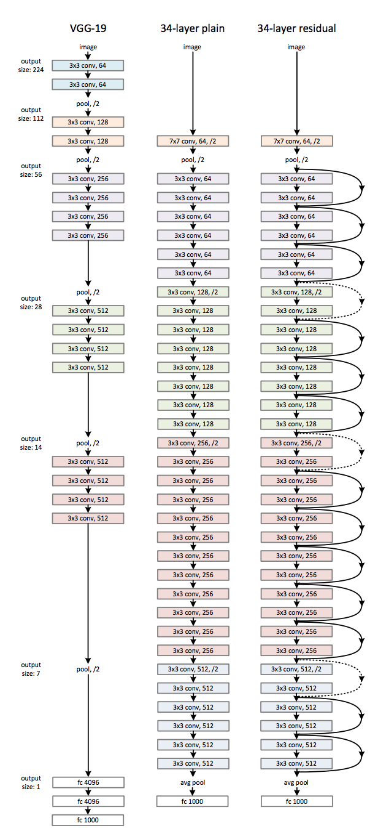

## Figure 31. ResNet Architecture

## Minigo Architecture

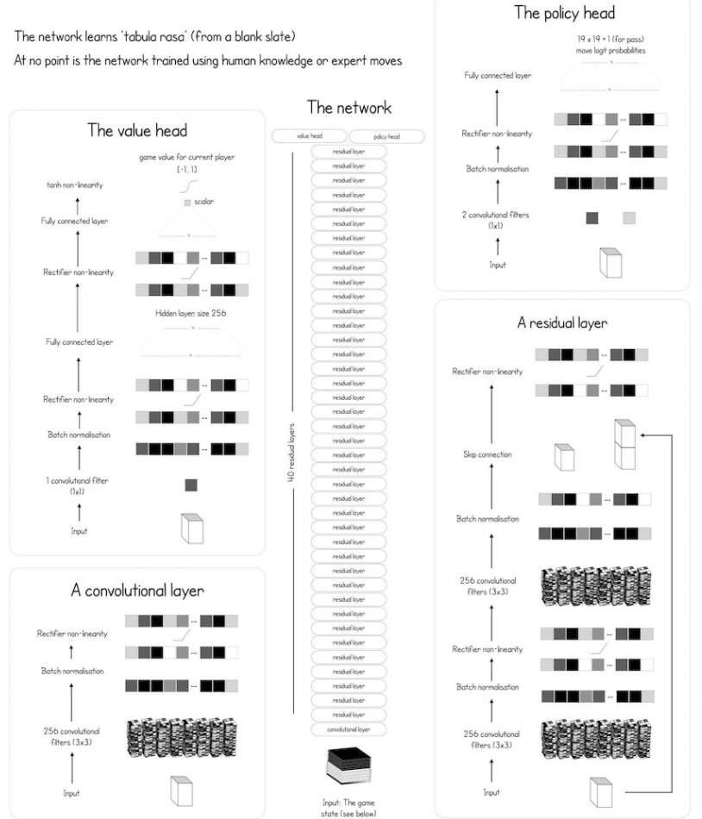

## Figure 32. Minigo architecture[21]

## HC Scatter

## Percentage Gain compared to Baseline

## Figure 33. HC Scatter

## HC Scatter

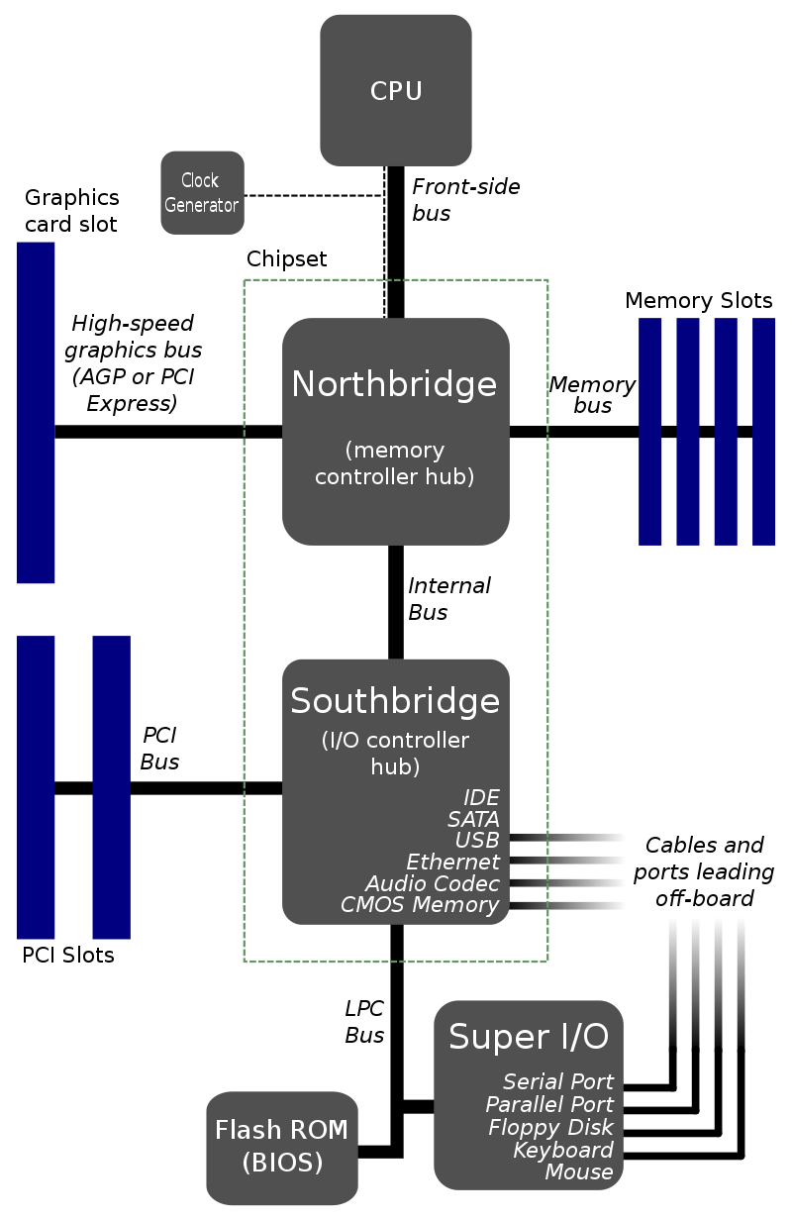

## Figure 34. Diagram of chipset [45]

## GANTT CHART

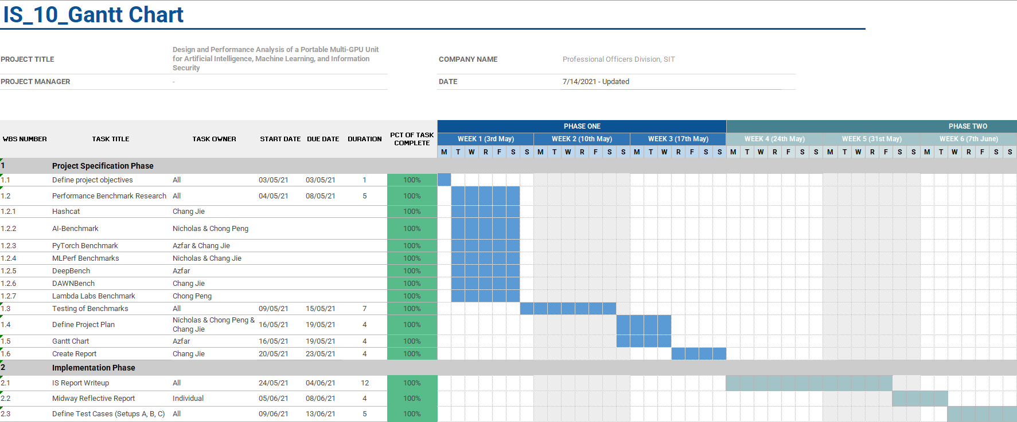

## Figure 35. Gantt Chart (Project Specification Phase)

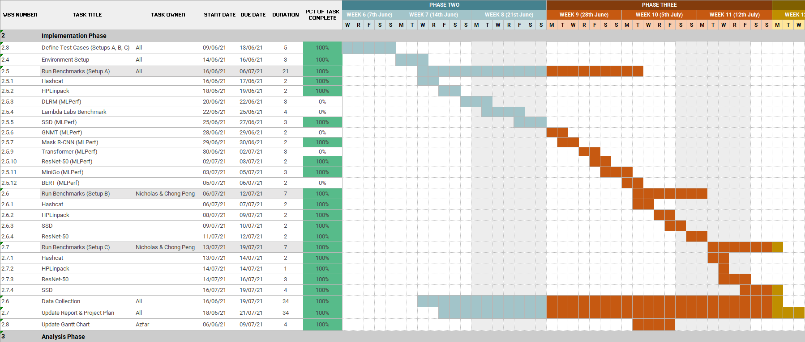

## Figure 36. Gantt Chart (Implementation Phase)

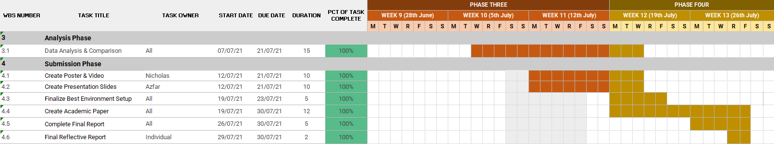

## Figure 37. Gantt Chart (Analysis and Submission Phase)

# REFERENCES

[1] Mattson P, Cheng C, Coleman C, Diamos G, Micikevicius P, Patterson D, et al. MLPerf Training Benchmark. 2019; Available from: http://arxiv.org/abs/1910.01500

[2] Petitet A, C., Whaley R, Dongarra J, Cleary A. HPL - A Portable Implementation of the High-Performance Linpack Benchmark for Distributed-Memory Computers [Internet]. 2018 [cited 2021 Jul 21]. Available from: https://www.netlib.org/benchmark/hpl/index.html

[3] Stanford University, Princeton University. ImageNet [Internet]. 2020 [cited 2021 Jul 21]. Available from: https://image-net.org/about.php

[4] Consortium C. COCO - Common Objects in Context [Internet]. COCO Consortium. 2015 [cited 2021 Jul 21]. Available from: https://cocodataset.org/#termsofuse

[5] Multimodal Brain Tumor Segmentation Challenge 2019: Registration [Internet]. The Trustees of the University of Pennsylvania. 2021 [cited 2021 Jul 21]. Available from: https://www.med.upenn.edu/cbica/brats2019/registration.html

[6] Criteo CAL. Criteo - About Us [Internet]. 2018 [cited 2021 Jul 21]. Available from: https://ailab.criteo.com/about-us/

[7] Mišić MJ, Durdević DM, Tomašević M V. Evolution and trends in GPU computing. MIPRO 2012 - 35th Int Conv Inf Commun Technol Electron Microelectron - Proc [Internet]. 2012;289–94. Available from: https://ieeexplore.ieee.org/abstract/document/6240658

[8] Osborne C. Cryptocurrency mining GPU demand hampers scientific research [Internet]. 2018 [cited 2021 Jul 26]. Available from: https://www.zdnet.com/article/cryptocurrency-mining-gpu-demand-hampers-scientific-research/

[9] Ignatov A. AI Benchmark for Windows, Linux and macOS: Let the AI Games Begin... [Internet]. Computer Vision Lab, ETH Zurich, Switzerland. 2021 [cited 2021 Jul 21]. Available from: https://ai-benchmark.com/alpha.html

[10] Coleman C, Kang D, Narayanan D, Bailis P, Zaharia M, University S. Ending Rolling Submissions for DAWNBench [Internet]. 2020 [cited 2021 Jul 21]. Available from: https://dawn.cs.stanford.edu/2020/01/13/end_dawnbench_rolling/

[11] MLCommons. MLCommons - v0.7 Results [Internet]. 2020 [cited 2021 Jul 26]. Available from: https://mlcommons.org/en/training-normal-07/

[12] Research B, GitHub. baidu-research/DeepBench [Internet]. 2016 [cited 2021 Jul 21]. Available from: https://github.com/baidu-research/DeepBench#types-of-operations

[13] Zhang Q, Zha L, Lin J, Tu D, Li M, Liang F, et al. A Survey on Deep Learning Benchmarks: Do We Still Need New Ones? [Internet]. Vol. 11459 LNCS, Lecture Notes in Computer Science (including subseries Lecture Notes in Artificial Intelligence and Lecture Notes in Bioinformatics). Springer International Publishing; 2019. 36–49 p. Available from: http://dx.doi.org/10.1007/978-3-030-32813-9_5

[14] Narang S, Diamos G, Goyal S. MLPerf: A New Benchmark for Deep Learning Models [Internet]. 2018 [cited 2021 Jul 26]. Available from: http://research.baidu.com/Blog/index-view?id=100

[15] Lambda. Deep Learning GPU Benchmarks [Internet]. [cited 2021 Jul 26]. Available from: https://lambdalabs.com/gpu-benchmarks

[16] Sprengers M. GPU-based Password Cracking [Internet]. Radboud University Nijmegen; 2011. Available from: https://www.ru.nl/publish/pages/769526/thesis.pdf

[17] Richter T. Evaluation of floating point image compression. Proc - Int Conf Image Process ICIP [Internet]. 2009;1909–12. Available from: https://ieeexplore.ieee.org/document/5413692

[16] Fatica M. Accelerating linpack with cuda on heterogenous clusters. Proc 2nd Work Gen Purp Process Graph Process Units, GPGPU-2 [Internet]. 2009;46. Available from: https://dl.acm.org/doi/10.1145/1513895.1513901

[17] Richter T. Evaluation of floating point image compression. Proc - Int Conf Image Process ICIP [Internet]. 2009;1909–12. Available from: https://ieeexplore.ieee.org/document/5413692

[18] Fatica M. Accelerating linpack with cuda on heterogenous clusters. Proc 2nd Work Gen Purp Process Graph Process Units, GPGPU-2 [Internet]. 2009;46. Available from: https://dl.acm.org/doi/10.1145/1513895.1513901

[19] Mattson P, Cheng C, Coleman C, Diamos G, Micikevicius P, Patterson D, et al. MLPerf Training Benchmark. 2019; Available from: http://arxiv.org/abs/1910.01500

[20] Hui J. SSD object detection: Single Shot MultiBox Detector for real-time processing [Internet]. 2018 [cited 2021 Jul 26]. Available from: https://jonathan-hui.medium.com/ssd-object-detection-single-shot-multibox-detector-for-real-time-processing-9bd8deac0e06

[21] ALPHAGO ZERO CHEAT SHEET [Internet]. [cited 2021 Jul 26]. Available from: https://adspassets.blob.core.windows.net/website/content/alpha_go_zero_cheat_sheet.png

[22] Silver D, Huang A, Maddison CJ, Guez A, Sifre L, Van Den Driessche G, et al. Mastering the game of Go with deep neural networks and tree search. Nature [Internet]. 2016;529(7587):484–9. Available from: https://www.researchgate.net/publication/292074166_Mastering_the_game_of_Go_with_deep_neural_networks_and_tree_search

[23] He K, Gkioxari G, Dollár P, Girshick R. Mask R-CNN. IEEE Trans Pattern Anal Mach Intell [Internet]. 2020;42(2):386–97. Available from: https://arxiv.org/pdf/1703.06870.pdf

[24] He K, Zhang X, Ren S, Sun J. Deep residual learning for image recognition. Proc IEEE Comput Soc Conf Comput Vis Pattern Recognit [Internet]. 2016;2016-Decem:770–8. Available from: https://arxiv.org/abs/1512.03385

[25] Mujtaba H. Introduction to Resnet or Residual Network [Internet]. 2020 [cited 2021 Jul 26]. Available from: https://www.mygreatlearning.com/blog/resnet/#sh13

[26] Devlin J, Chang MW, Lee K, Toutanova K. BERT: Pre-training of deep bidirectional transformers for language understanding. NAACL HLT 2019 - 2019 Conf North Am Chapter Assoc Comput Linguist Hum Lang Technol - Proc Conf [Internet]. 2019;1(Mlm):4171–86. Available from: https://arxiv.org/pdf/1810.04805.pdf

[27] Wu Y, Schuster M, Chen Z, Le Q V., Norouzi M, Macherey W, et al. Google’s Neural Machine Translation System: Bridging the Gap between Human and Machine Translation. 2016;1–23. Available from: http://arxiv.org/abs/1609.08144

[28] Vaswani A, Shazeer N, Parmar N, Uszkoreit J, Jones L, Gomez AN, et al. Attention is all you need. Adv Neural Inf Process Syst [Internet]. 2017;2017-Decem(Nips):5999–6009. Available from: https://arxiv.org/pdf/1706.03762.pdf

[29] Naumov M, Mudigere D, Shi H-JM, Huang J, Sundaraman N, Park J, et al. Deep Learning Recommendation Model for Personalization and Recommendation Systems. 2019; Available from: http://arxiv.org/abs/1906.00091

[30] Petitet A, C., Whaley R, Dongarra J, Cleary A. HPL Algorithm [Internet]. 2018 [cited 2021 Jul 26]. Available from: http://www.netlib.org/benchmark/hpl/algorithm.html

[31] Inc PT. Pex 8614 [Internet]. 2009. p. 4. Available from: https://docs.broadcom.com/doc/12351827

[32] NVIDIA Corporation. CUDA Accelerated Linpack for Linux64 [Internet]. NVIDIA Corporation; Available from: https://developer.nvidia.com/rdp/assets/cuda-accelerated-linpack-linux64

[33] Petitet A, C., Whaley R, Dongarra J, Cleary A. HPL Tuning [Internet]. 2018 [cited 2021 Jul 26]. Available from: https://www.netlib.org/benchmark/hpl/tuning.html

[34] MLCommons, GitHub. MLCommons [Internet]. [cited 2021 Jul 26]. Available from: https://github.com/mlcommons

[35] Kharya P, NVIDIA Corporation. NVIDIA Breaks Eight AI Performance Records [Internet]. 2019 [cited 2021 Jul 26]. Available from: https://blogs.nvidia.com/blog/2019/07/10/mlperf-ai-performance-records/

[36] Szotucha M. Case Study: ResNet50 with DALI [Internet]. 2019 [cited 2021 Jul 26]. Available from: https://developer.nvidia.com/blog/case-study-resnet50-dali/

[37] Cecilia S. Implementing ResNet with MXNET Gluon and Comet.ml for image classification [Internet]. 2018 [cited 2021 Jul 26]. Available from: https://medium.com/apache-mxnet/implementing-resnet-with-mxnet-gluon-and-comet-ml-for-image-classification-9bb4ad93a53f

[38] Saleem U. GPU Boost – Nvidia’s Self Boosting Algorithm Explained [Internet]. 2020 [cited 2021 Jul 26]. Available from: https://appuals.com/gpu-boost-nvidias-self-boosting-algorithm-explained/

[39] Wikimedia Foundation. Northbridge (computing) [Internet]. [cited 2021 Jul 26]. Available from: https://en.wikipedia.org/wiki/Northbridge_(computing)

[40] Mkelvin. PCIe Lanes explained [Internet]. 2018 [cited 2021 Jul 26]. Available from: https://cotscomputers.com/blog/pcie-lanes/

[41] Wikimedia Foundation. Southbridge (computing) [Internet]. [cited 2021 Jul 26]. Available from: https://en.wikipedia.org/wiki/Southbridge_(computing)

[42] Nguyen V, Burc Eryilmaz S, Narasimhan S, Onofrio D. MLPerf v1.0 Training Benchmarks: Insights into a Record-Setting NVIDIA Performance [Internet]. 2021 [cited 2021 Jul 26]. Available from: https://developer.nvidia.com/blog/mlperf-v1-0-training-benchmarks-insights-into-a-record-setting-performance/

[43] MLCommons, GitHub. mlcommons/training/tree/master/single_stage_detector/ssd [Internet]. [cited 2021 Jul 26]. Available from: https://github.com/mlcommons/training/tree/master/single_stage_detector/ssd

[44] Stanford University, Princeton University. Download ImageNet Data [Internet]. [cited 2021 Jul 26]. Available from: https://image-net.org/download-images

[45] Wikimedia Foundation. File:Motherboard diagram.svg [Internet]. 2007 [cited 2021 Jul 26]. Available from: https://commons.wikimedia.org/w/index.php?curid=3789066

[46] Menze BH, Jakab A, Bauer S, Kalpathy-Cramer J, Farahani K, Kirby J, et al. The Multimodal Brain Tumor Image Segmentation Benchmark (BRATS). IEEE Trans Med Imaging [Internet]. 2015;34(10):1993–2024. Available from: https://ieeexplore.ieee.org/stamp/stamp.jsp?tp=&arnumber=6975210

[47] Bakas S, Akbari H, Sotiras A, Bilello M, Rozycki M, Kirby JS, et al. Advancing The Cancer Genome Atlas glioma MRI collections with expert segmentation labels and radiomic features. Sci Data [Internet]. 2017;4(July):1–13. Available from: https://www.nature.com/articles/sdata2017117.pdf

[48] Bakas S, Reyes M, Jakab A, Bauer S, Rempfler M, Crimi A, et al. Identifying the Best Machine Learning Algorithms for Brain Tumor Segmentation, Progression Assessment, and Overall Survival Prediction in the BRATS Challenge. 2018; Available from: http://arxiv.org/abs/1811.02629